 

## South Valley University

Faculty of Computer and Information Technology

Computer Science and Information Technology Departments

Final Year Project

Student Management System

Tazkartak

Presented By:

|  |  |
| --- | --- |
| *Ahmed EzzEldin Turki* | *Osama Abdellah Osman* |
| *Ahmed Salah Mohamed*  *Ahmed Refaat AbdElNagi*  *Ahmed Yahya Mohamed* | *Ali Hassan Mohamed*  *Mohamed Ahmed AbdElrazik* |

Supervised By:

*DR. Sara Farrag*

Students’ contributions

Bus reservation system (Tazkartak) By:

|  |  |  |
| --- | --- | --- |
|  | *Title* | *Contributors* |
| *1* | *UX/UI* | *Ahmed Salah Mohamed* |
| *2* | *Front-end developer* | *Ahmed EzzEldin Turki*  *Ahmed Refaat AbdElnagi*    *Ahmed Yahya Mohamed* |
| *3* | *back-end developer* | *Osama Abdellah Osman*  *Ali Hassan Mohamed*  *Mohamed Ahmed Abdelrazik* |
| *4* | *Book* | *Ahmed EzzEldin Turki*  *Ahmed Yahya Mohamed*  *Ahmed Refaat AbdElnagi* |

# Chapter 1:

##### Software Requirements Specification

**1.10 Introduction**

Tazkrtak is a project aimed at developing a comprehensive platform for booking local bus tickets, providing a seamless and reliable user experience. The platform offers a unique feature allowing users to refund their tickets in case of cancellation, subject to a cancellation fee, provided the cancellation is made at least five hours before the scheduled trip. This feature enhances user trust in public transportation services. The project targets all segments of society, from students to tourists, offering a variety of options from local bus companies. With a vision for future expansion through the integration of new technologies, Tazkrtak aims to improve public transportation services and simplify travel experiences for citizens..



**1.10.1**



**Purpose**

This document aims to define the functional and non-functional requirements for an online bus ticket reservation system. The system is designed to enable users to easily book tickets for any local bus company while introducing an innovative feature that allows users to receive a refund upon cancellation of their reservation by reassigning the ticket to another person.



**1.10.2**



**Project Scope**

The system encompasses all bus companies operating within the country, making it easier for users to book tickets, select trip schedules, and choose their preferred company. Additionally, the system offers an online ticket cancellation feature, allowing cancellations up to a maximum of five hours before the trip.

This section provides an overall description of **Tazkartak**, including its key features, user classes, and the operating environment in which it will function.



**1.11 Overall Description**

**1.11.1Product features**

**Tazkartak** offers a comprehensive set of features designed to book local bus tickets . Key product features include:

##### Administration

**Personal Data Management:** Administrators can manage their personal information, contact details.

* + **Manage Companies:**
    - Add Company
    - Delete Company
    - Edit Company Trips
    - Edit Company
  + **Manage Users:**
    - Show , delete and edit users information.

##### Users

* + **Personal Data Management**: Users can manage their personal information, contact details.
  + **Trips:** SearchView Available Trips.
  + **Tickets:** Choose seats, payment, book, cancel,View their Tickets.

##### Companies

* + **Personal Data Management:** Company can manage their personal information, contact details.
  + **Trip Management:** View and manage trips.
  + **Booked Tickets:** View and manage Booked Tickets

Tazkartak is built using .NET Core 8, Entity Framework Core, SQL Server, React JS for the front end, and is hosted on Monster ASP.NET for API services.



**1.11.2**



**User Classes and Characteristics**

Tazkartak caters to various user classes, each with distinct characteristics and requirements:

##### Users:

* + Use the system for book a Ticket, view all trips by search, pay for his ticket and cancel booking.
  + Require a user-friendly interface

##### Companies:

* + Need tools for efficient communication with users and companies.

##### Administrators:

* They have control over every aspect of the system to ensure its proper functioning and to address any issues that may arise.
  + Require comprehensive access to all system functionalities.



**1.11.3**



**Operating Environment**

* + - 1. ***Hardware:***
         * **Servers**: The Tazkartak system requires one or more servers to host the application, database, and associated services. These servers should be equipped with adequate processing power, memory, and storage capacity to handle concurrent user access and data storage requirements. Given the scale of the system and the anticipated user load, high-performance servers are recommended to ensure seamless operation.
         * **Client Devices**: Tazkartak will be accessible from various client devices, including desktop computers, laptops, tablets, and smartphones. Ensuring compatibility with different operating systems (Windows, macOS, Linux, iOS, Android) and web browsers (Chrome, Firefox, Safari, Edge) is essential to provide broad accessibility and a consistent user experience.
      2. ***Software:***
         * **Operating System**: Operating System: The servers hosting the Tazkartak system can run on operating systems such as Linux, Windows Server, or macOS Server, based on the preferences and expertise of the system administrators.
         * **Database Management System (DBMS**): Tazkartak will utilize Microsoft SQL Server (MSSQL) for storing and managing system data, including student records, course information, and user accounts. MSSQL is chosen for its robustness, security features, and seamless integration with the .NET framework.
         * **Application Framework**: The system will be built using the .NET 8 framework, leveraging its comprehensive set of tools and libraries for developing web-based applications efficiently.
         * **Programming Languages:** C# will be the primary programming language used for developing the Tazkartak system, given its compatibility with the

.NET framework and its strong support for building scalable and maintainable applications.

* + - 1. ***Network Infrastructure:***
         * **Internet Connectivity:** Internet access is crucial for users to connect to Tazkartak from remote locations outside the institution's network. Reliable and high-speed internet connectivity will ensure that the system remains accessible to all users, regardless of their location.
      2. ***Backup and Disaster Recovery:***

Regular data backups and a comprehensive disaster recovery plan are critical to mitigate the risk of data loss and ensure the continuity of service. These measures will address potential hardware failures, software glitches, or other unforeseen events that could disrupt the system. Backups will be performed routinely, and recovery procedures will be tested periodically to ensure the system can be restored quickly and effectively in the event of a disaster.



**1.12 System Features**



**1.12.1**



**User Management**

The TAZKARTAK system includes comprehensive user management features, enabling different types of users to access and manage their data effectively. The primary user roles include Administrators, Users, Companies. Each role has specific pages and functionalities tailored to their needs:

* + - 1. ***Administration:***

Personal Data, Contact Data.

**Roles:**

* + - * 1. **Manage Companies :**

Add Company

Delete Company

Edit Company

Edit Company Trips

* + - * 1. **Manage Users:**

Show, Add, Delete, Edit User

* + - 1. **Users*:***

Personal Data, Contact Data.

**Roles**:

* View Trips of all companies
* View Available Seats in the Chosen Trip.
* Show, Edit and Delete Account.
* Book and retrieve tickets.
  + - 1. ***Companies:***

Personal Data, Contact Data.

**Roles:**

* + - * 1. **Manage Trips:**

Add, Edit and Delete Trip

* + - * 1. **Manage Tickets:**

Specifying Ticket Quantity and Price



**1.13 Other Nonfunctional Requirements**



**1.13.1**



**Security Requirements**

Security is a critical aspect of the TAZKARTAK system to ensure the protection of sensitive data and maintain user privacy. The system includes several security measures:

1. **Authentication and Authorization:**
   * Users must authenticate using secure login credentials.
   * Role-based access control ensures users can only access data and functions pertinent to their roles.



**1.14 Use case Diagram**

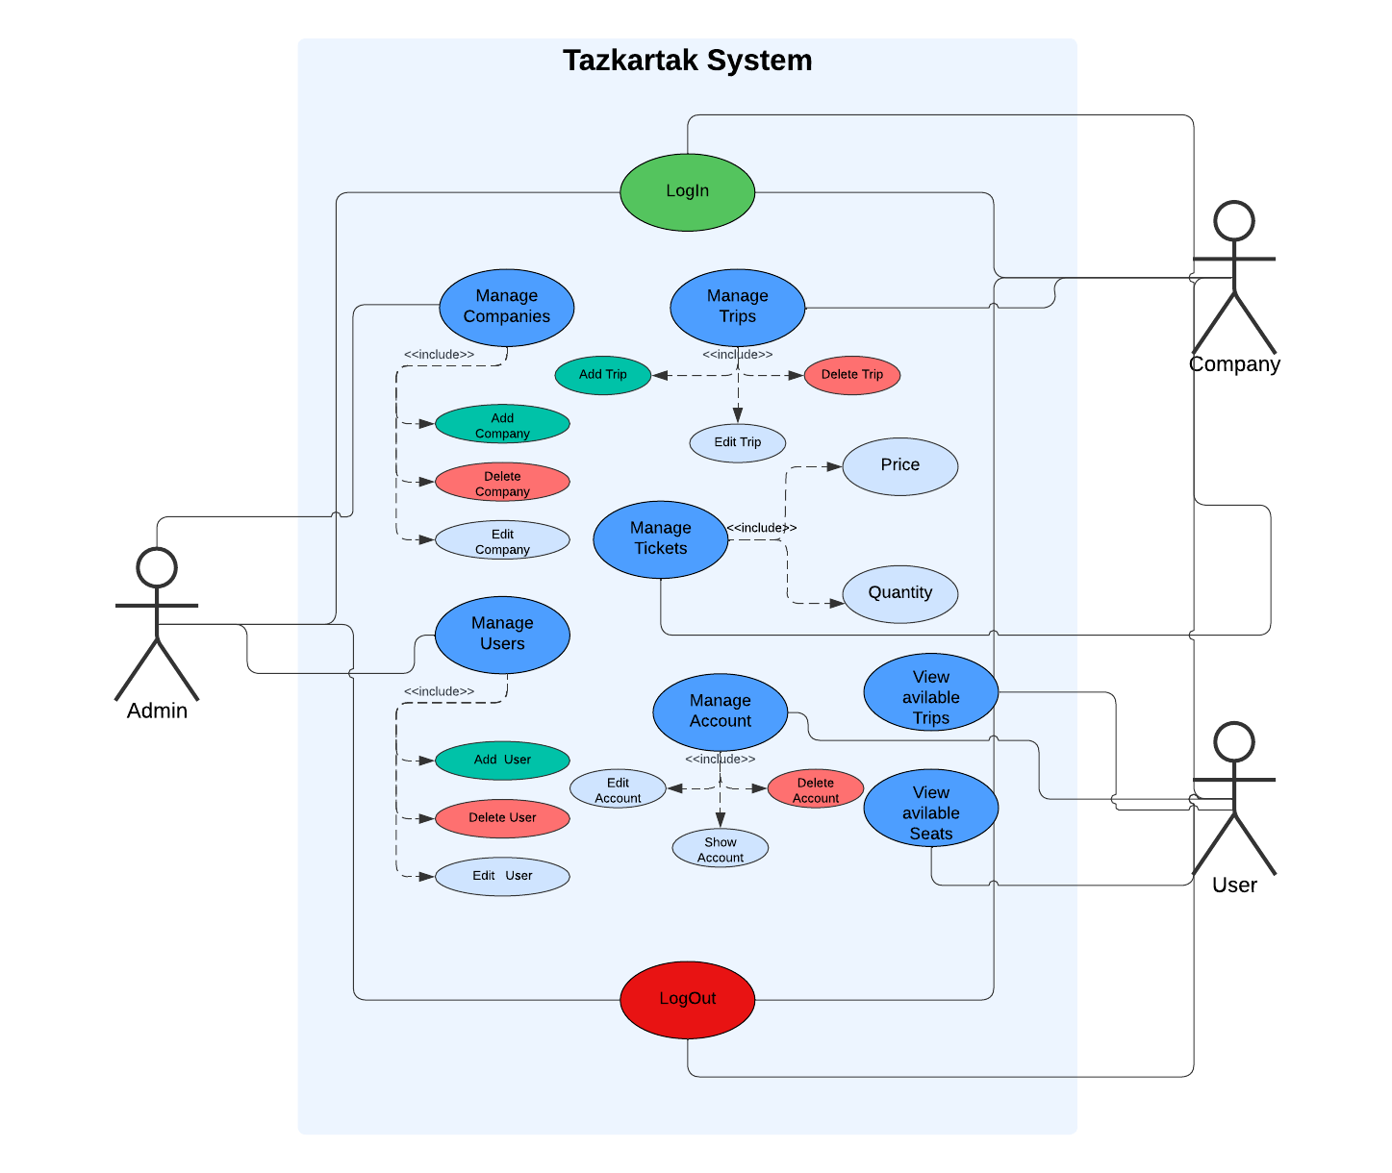

**Class diagram**

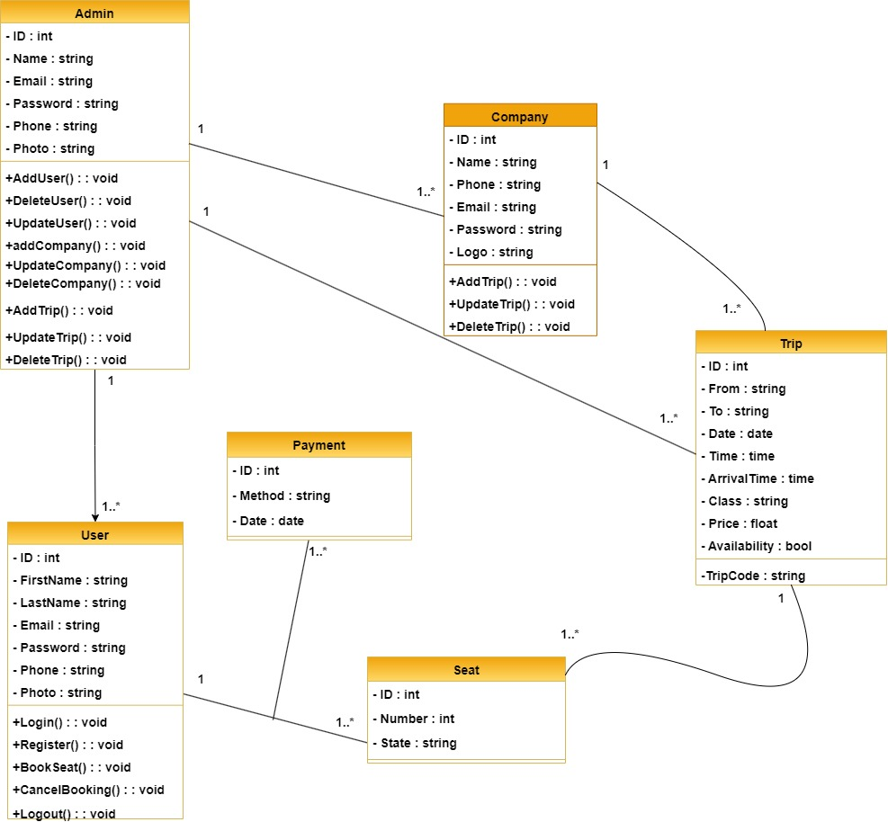

**ERD**

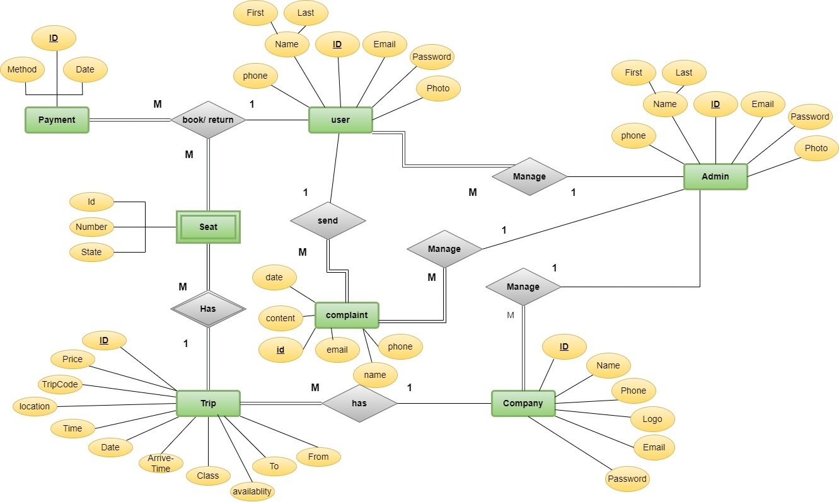

**Sequence diagram**

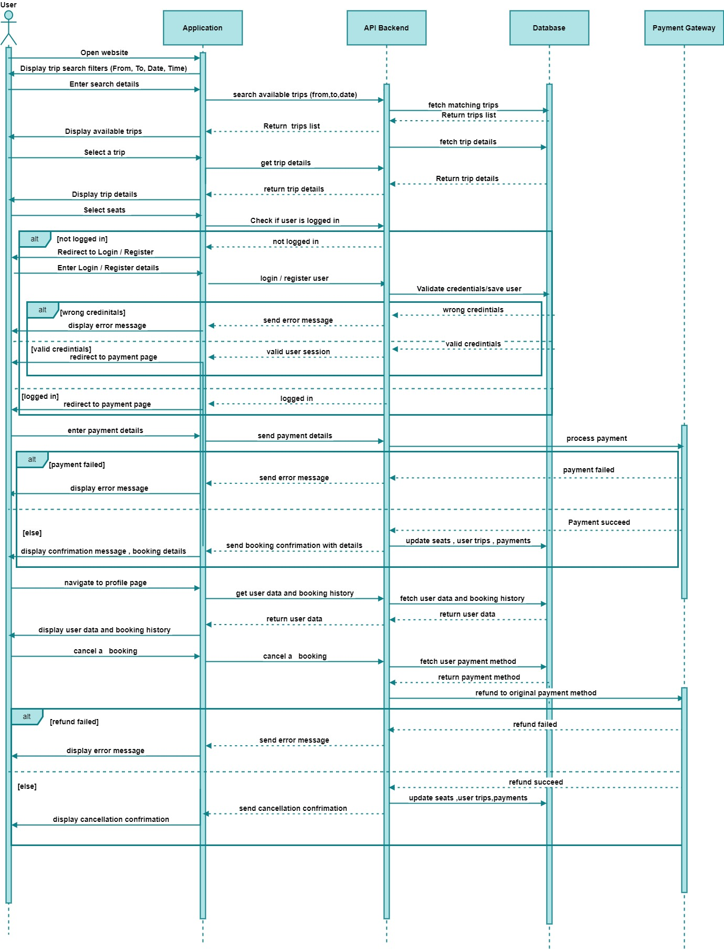

# Chapter 2:

#### Results

**Start Page**

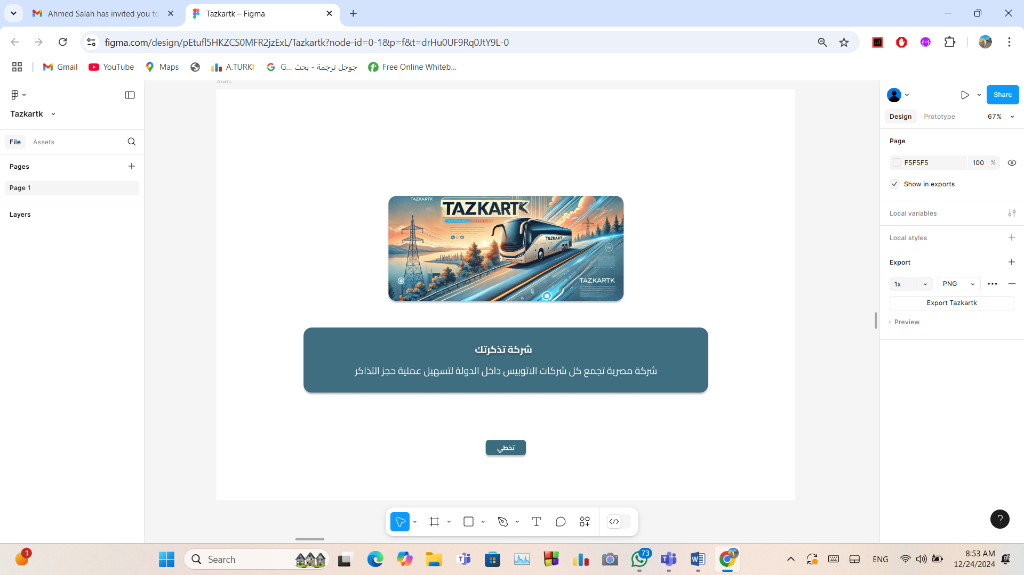

**Home Page**

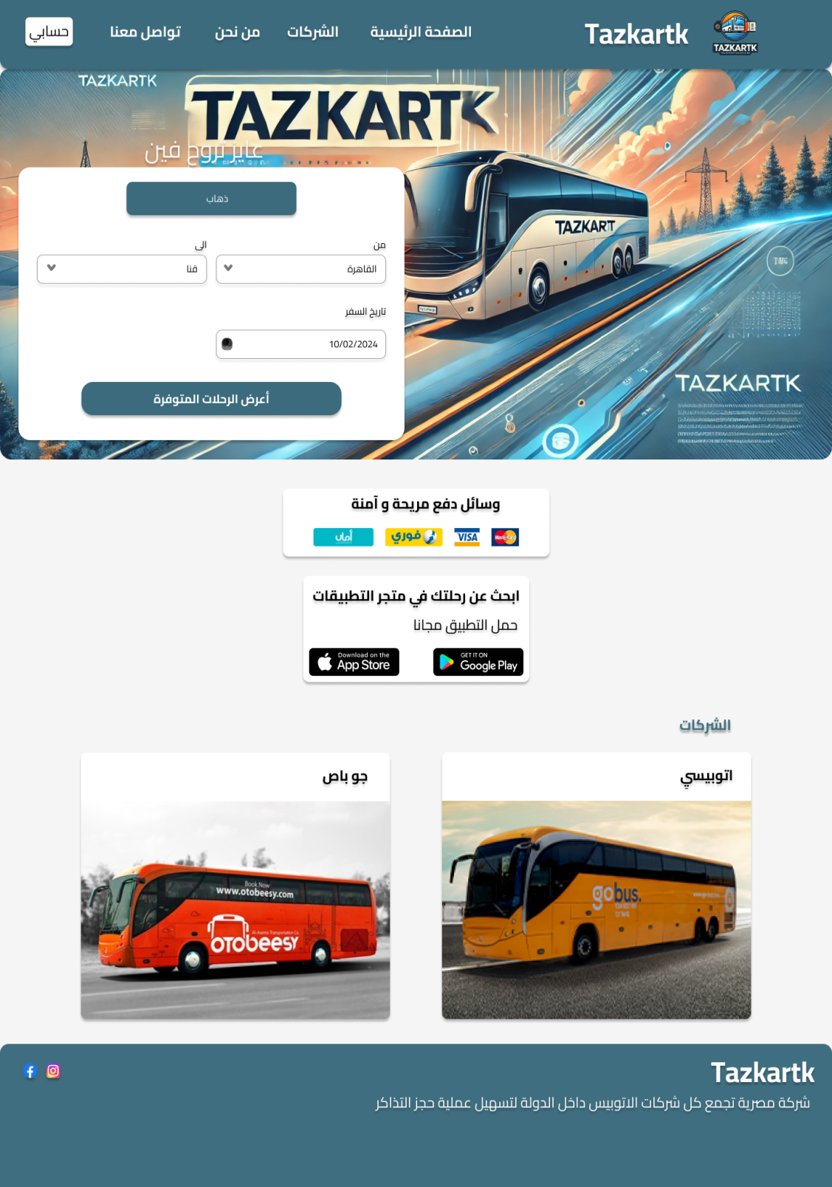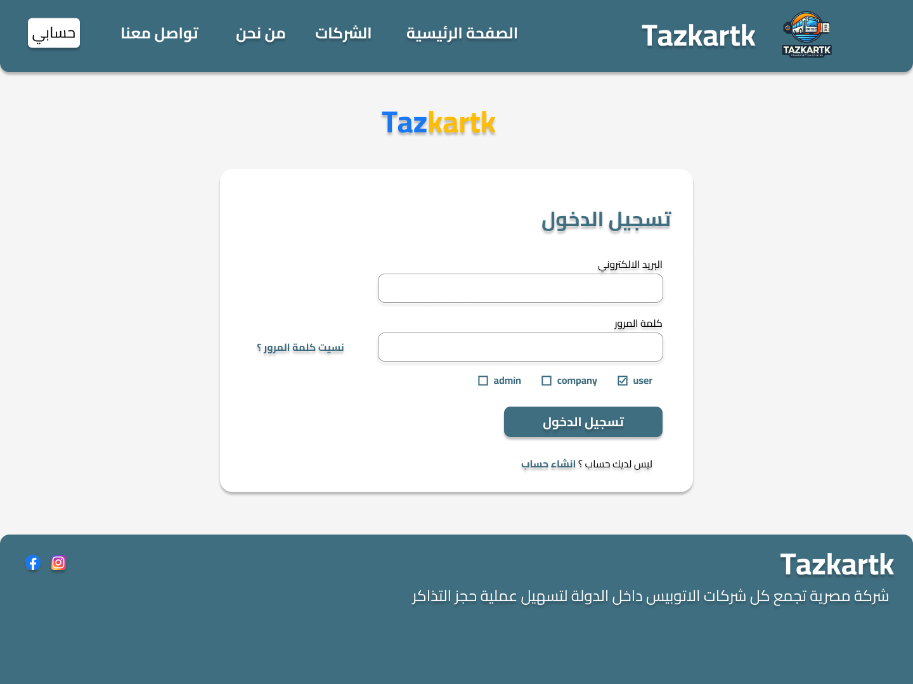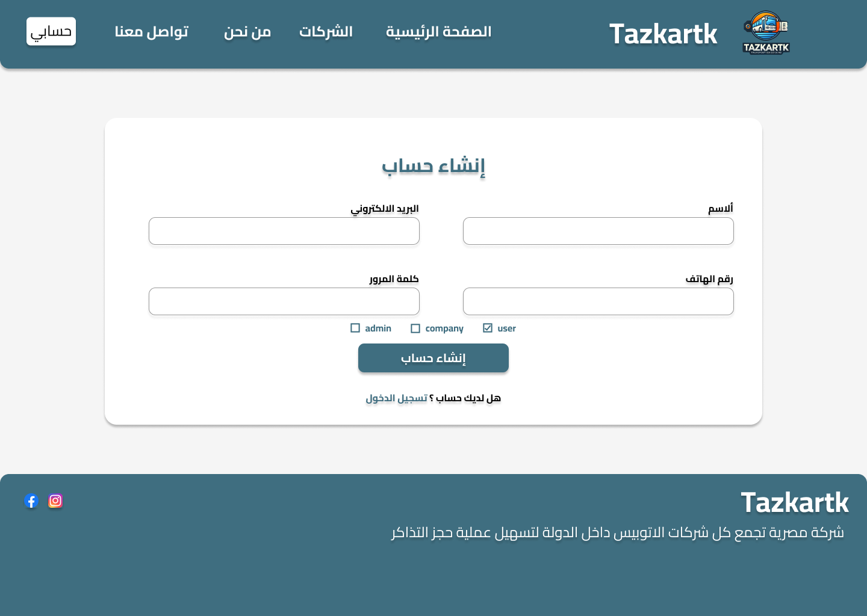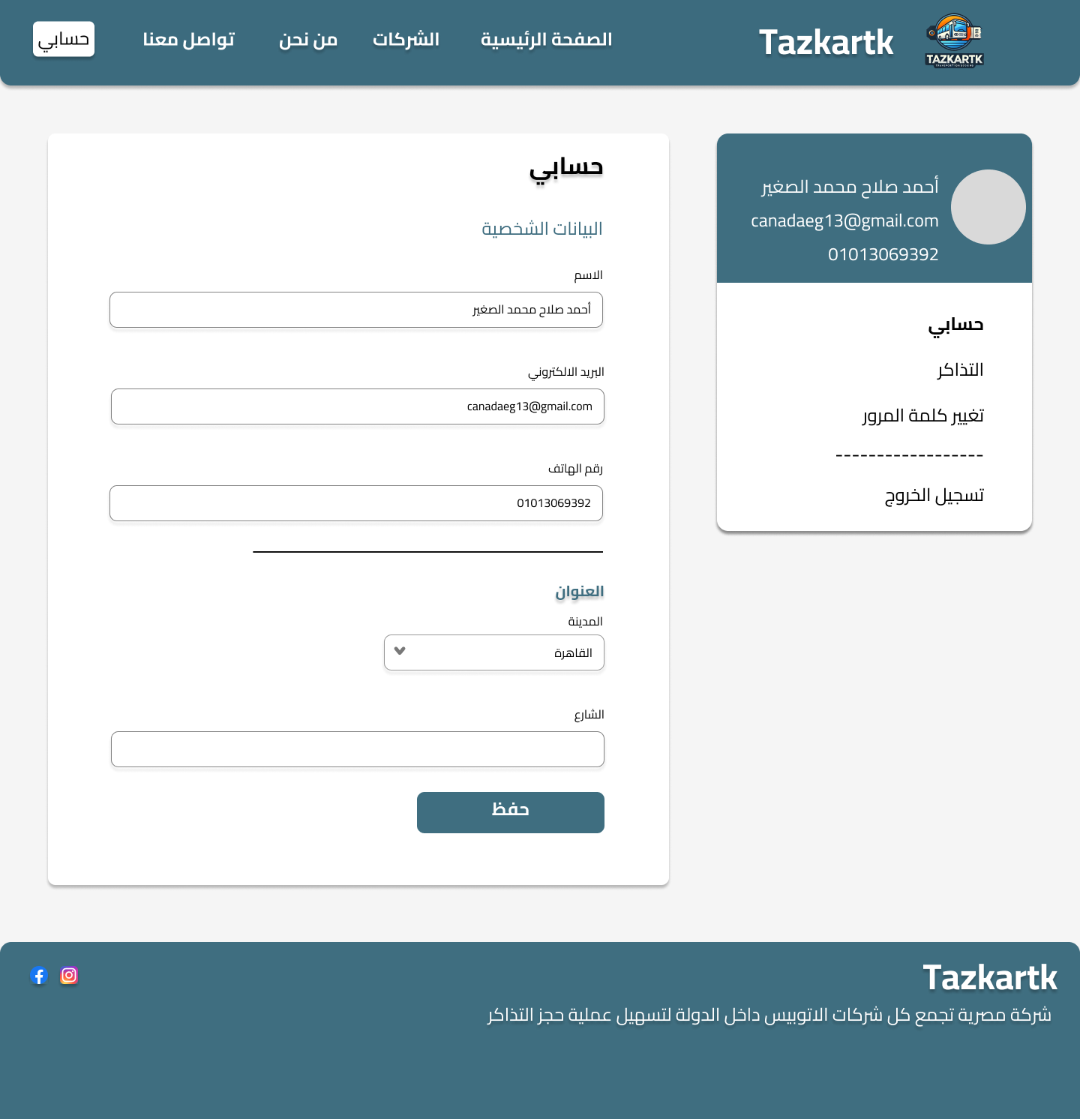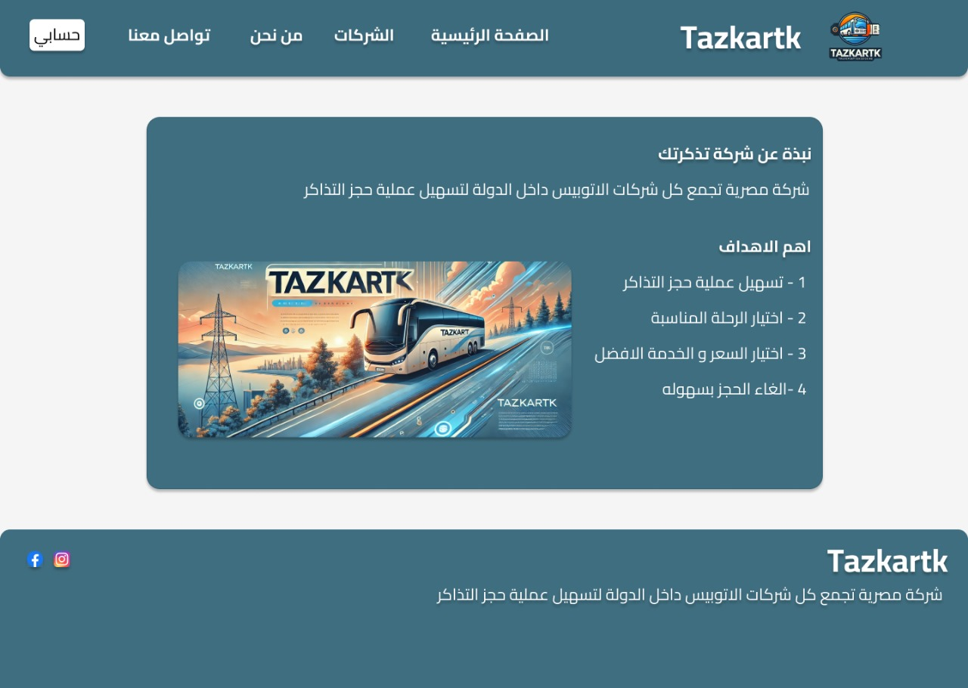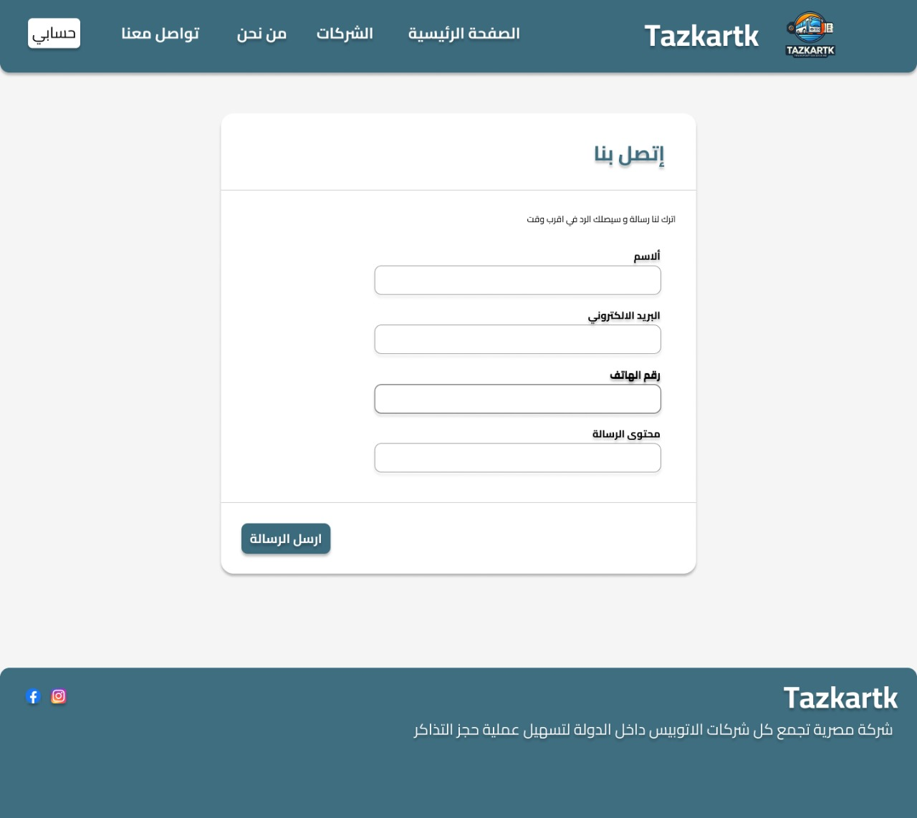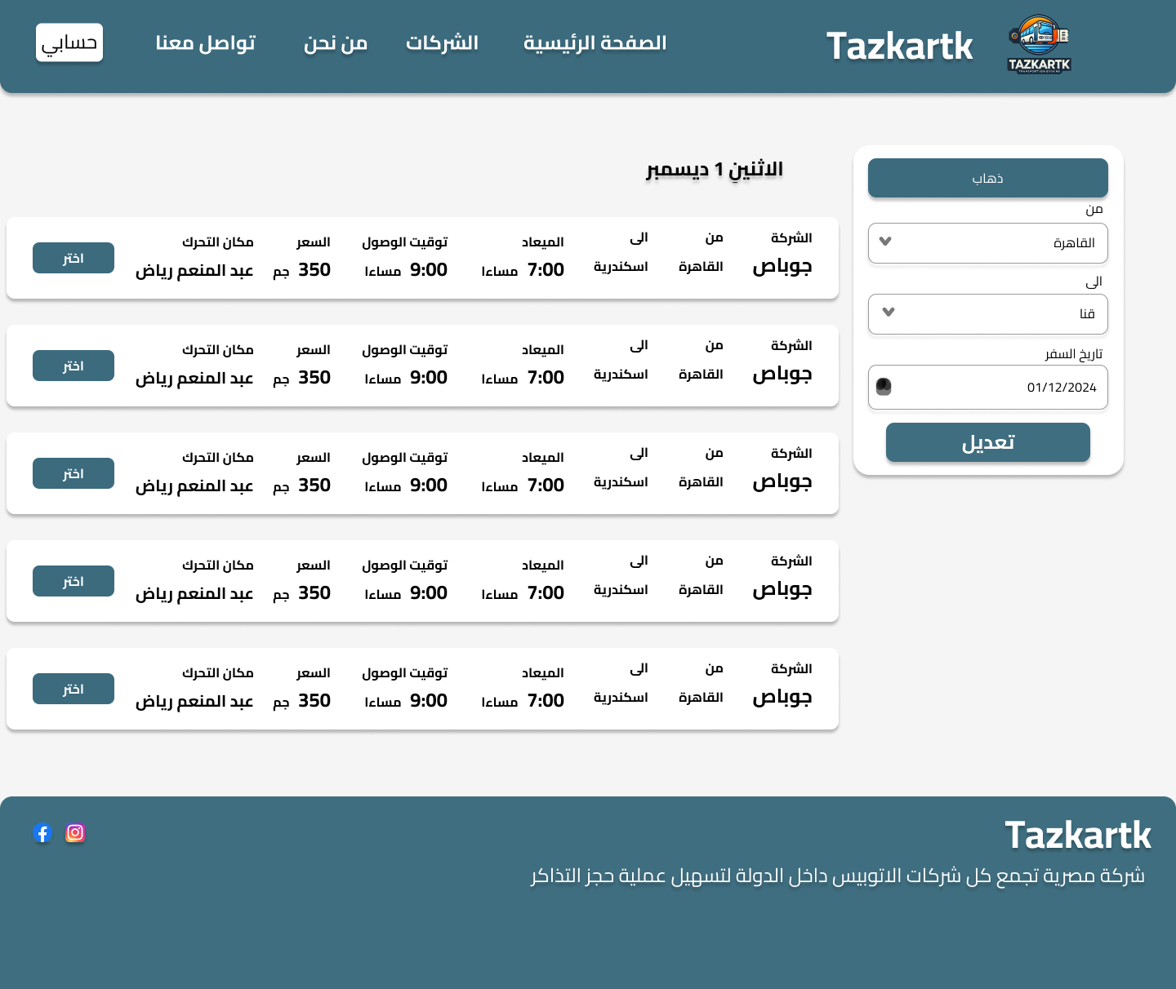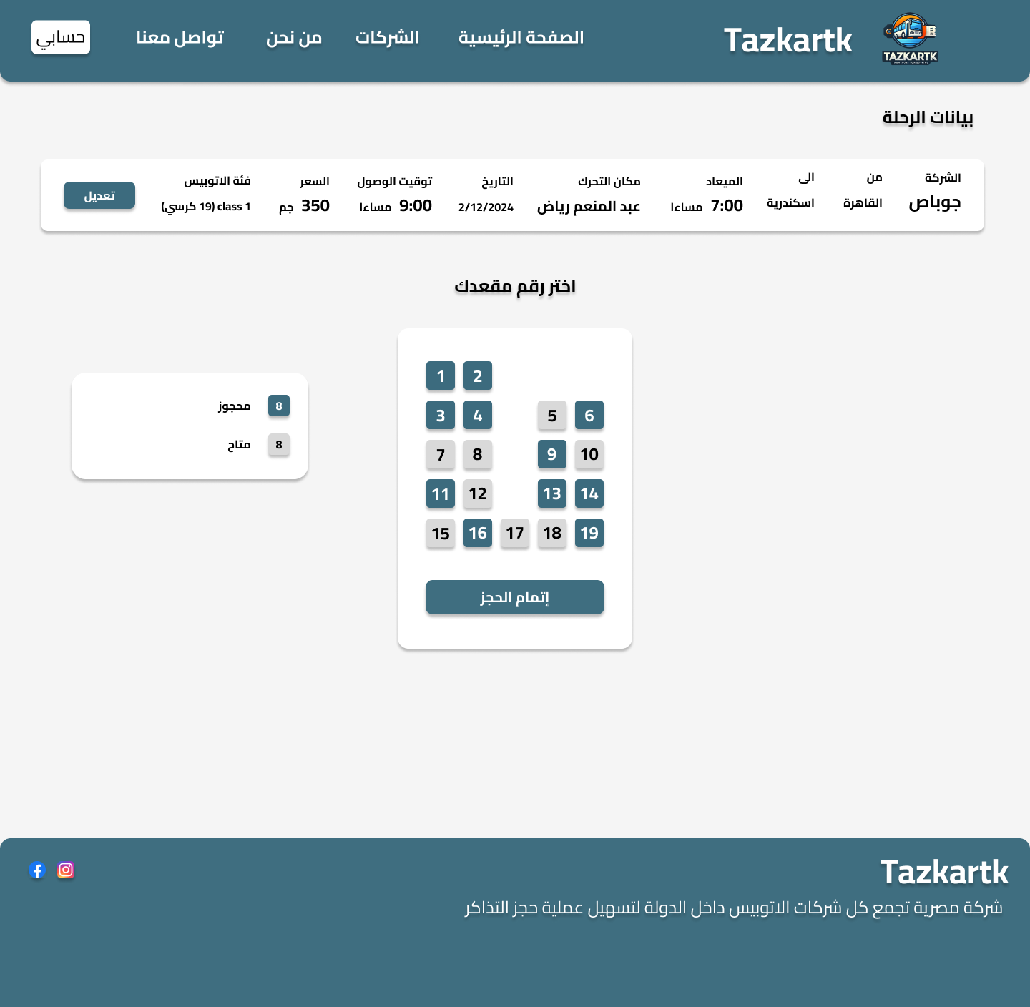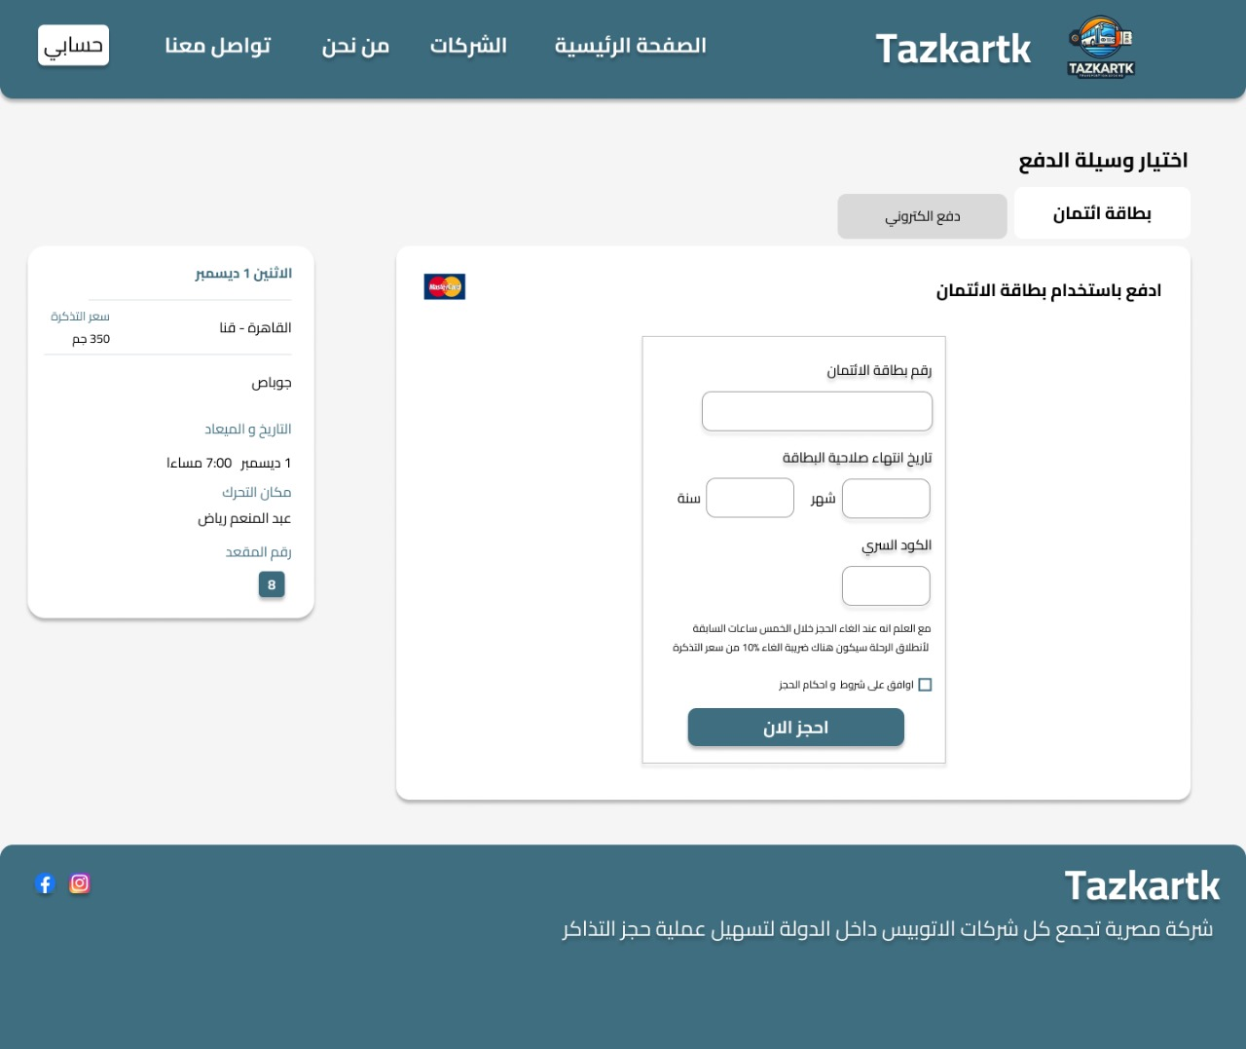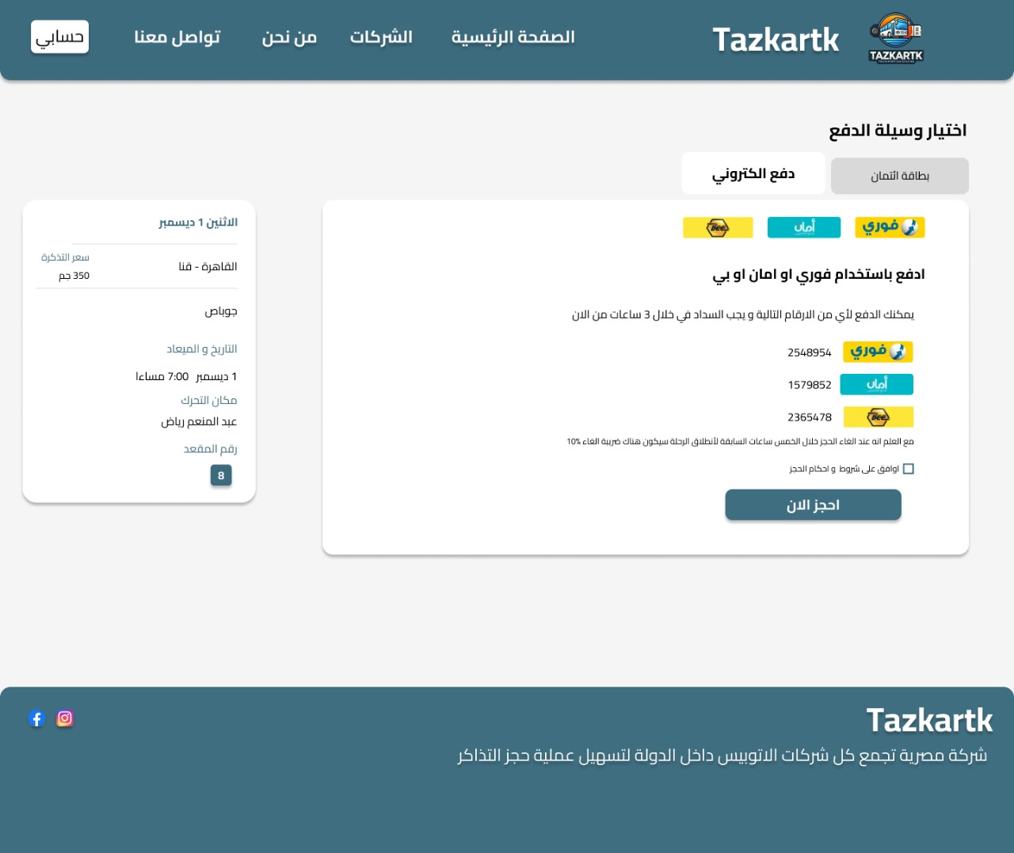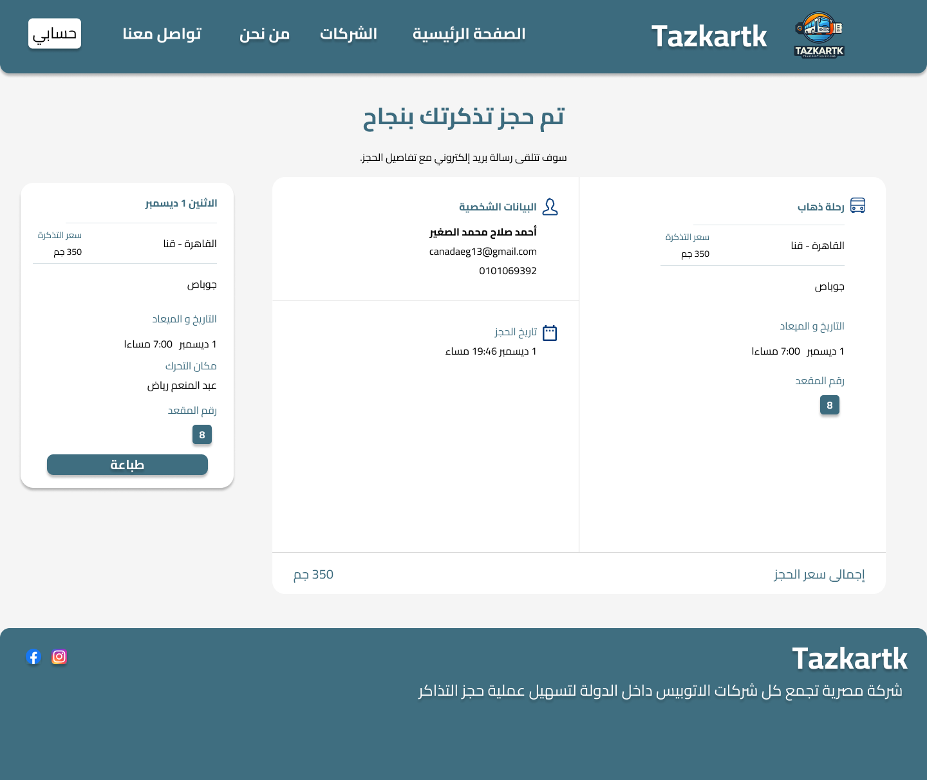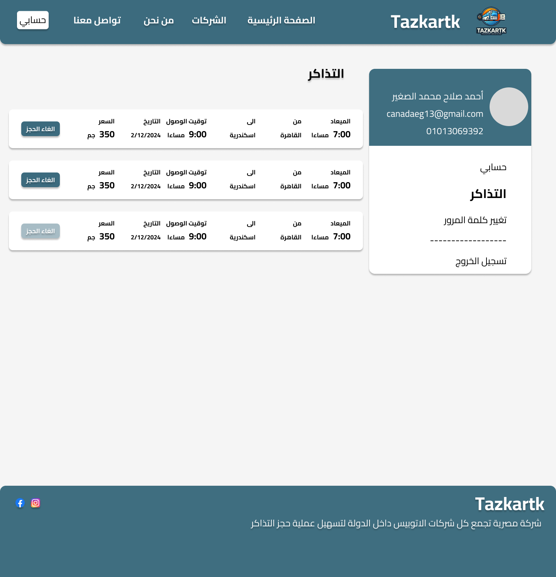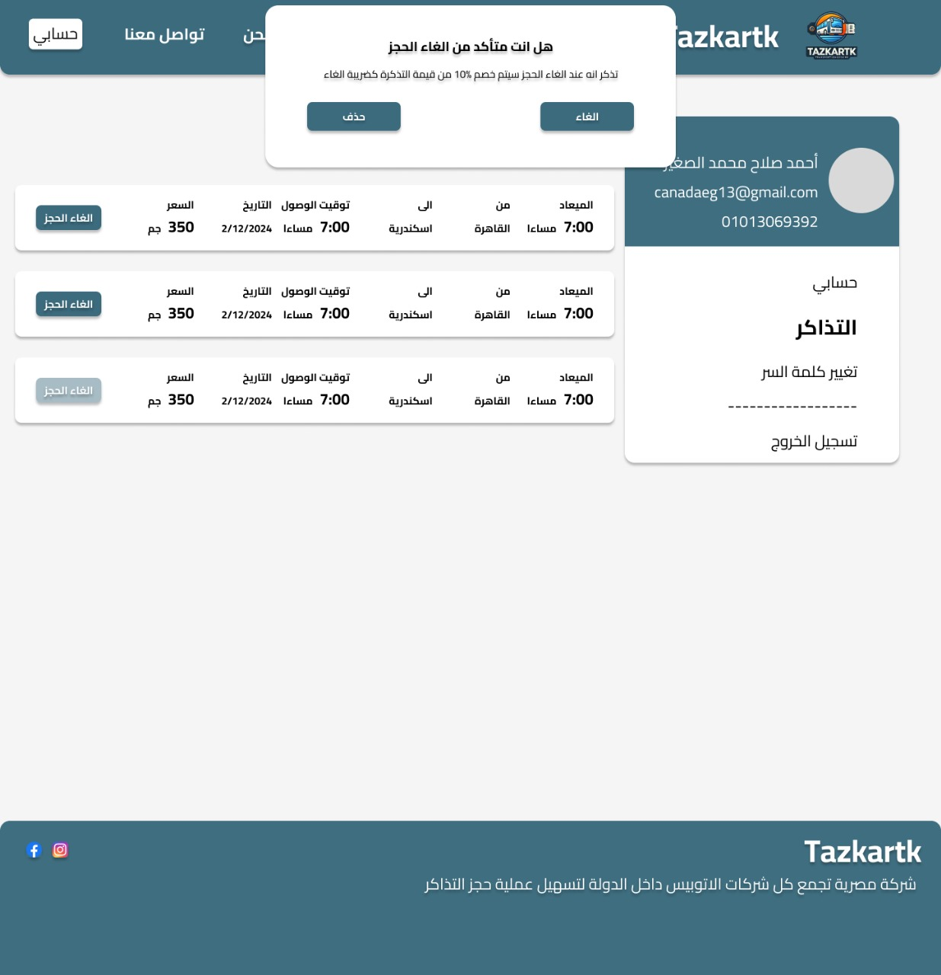

**Administration**

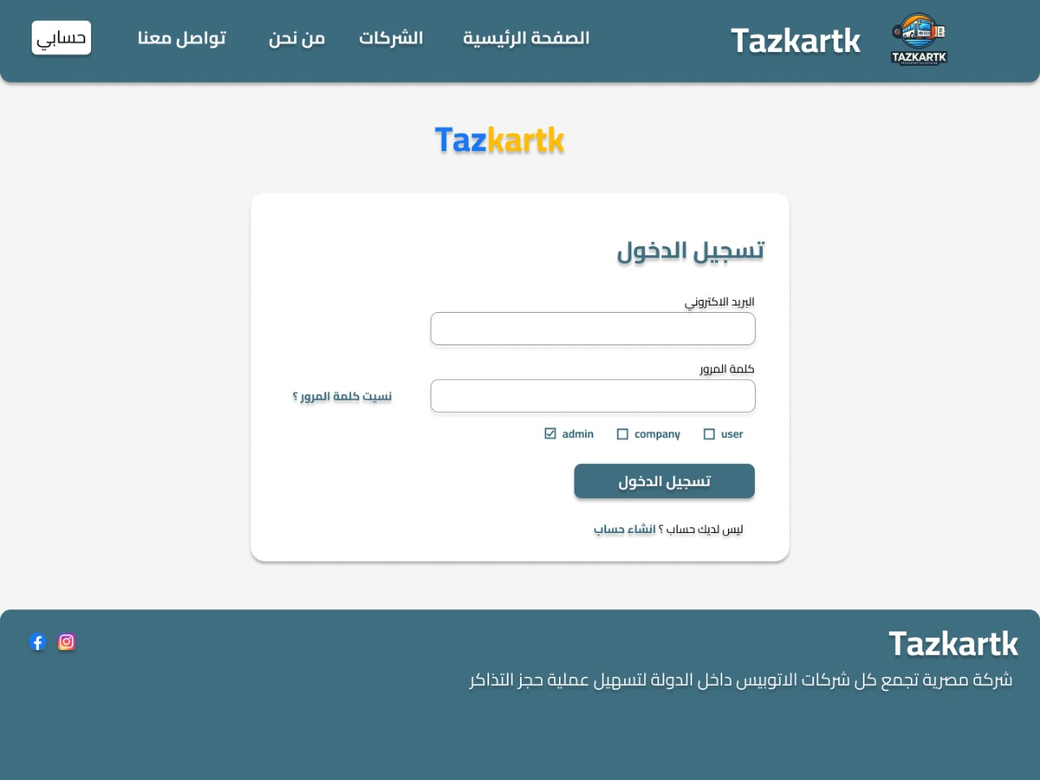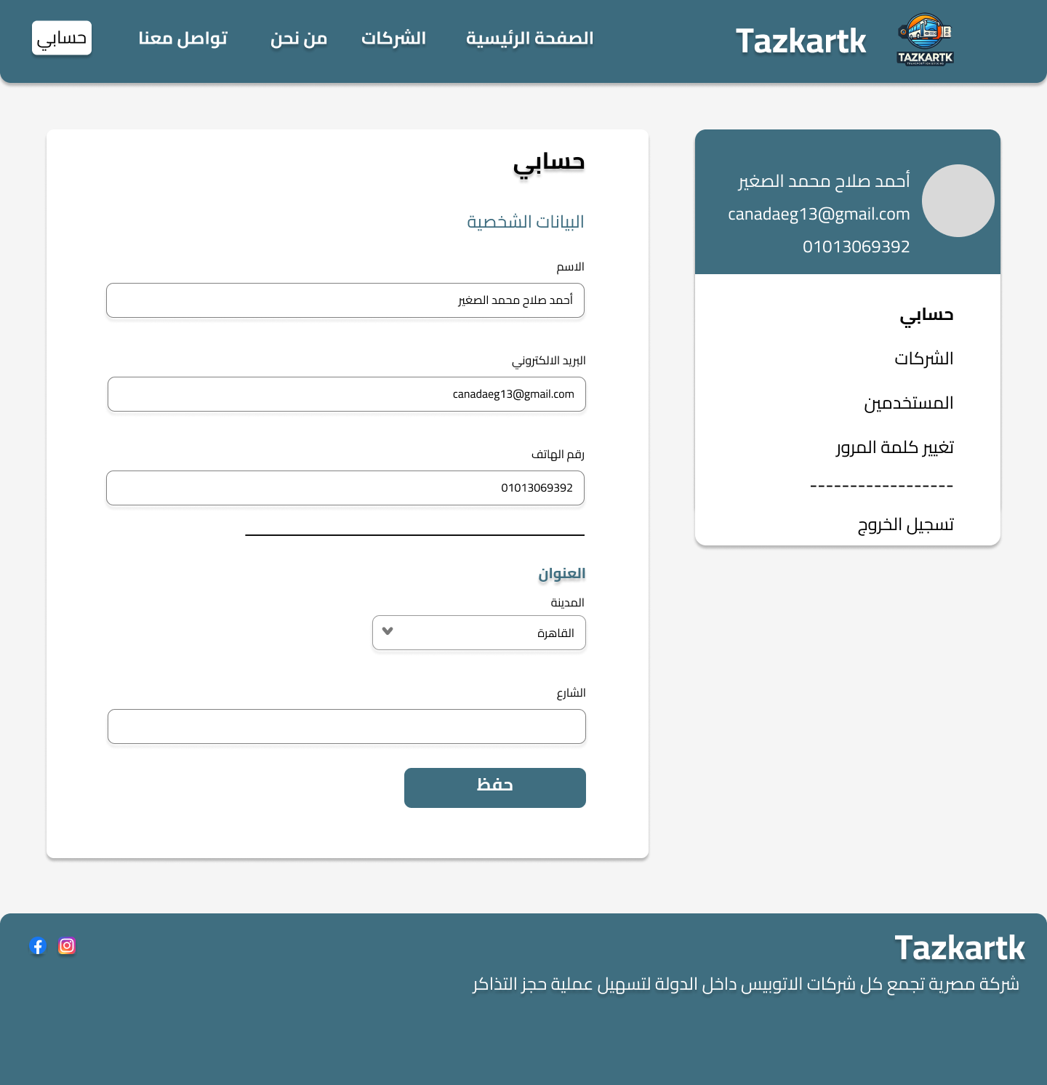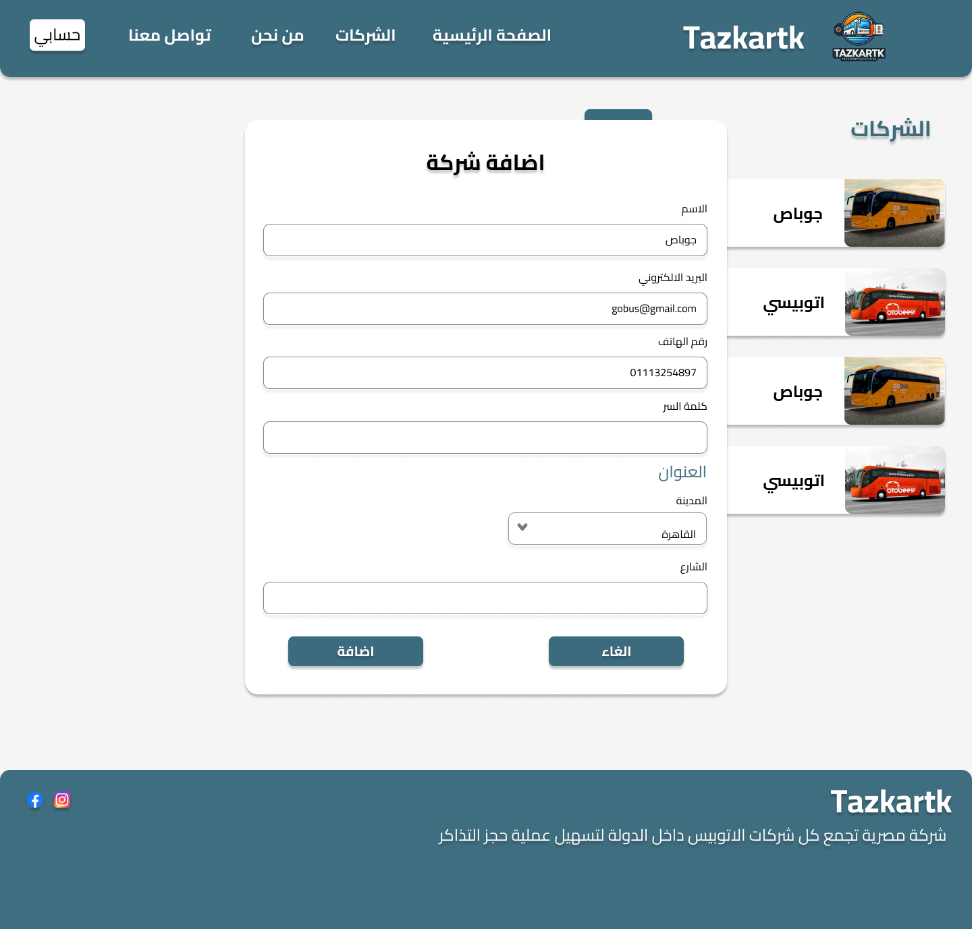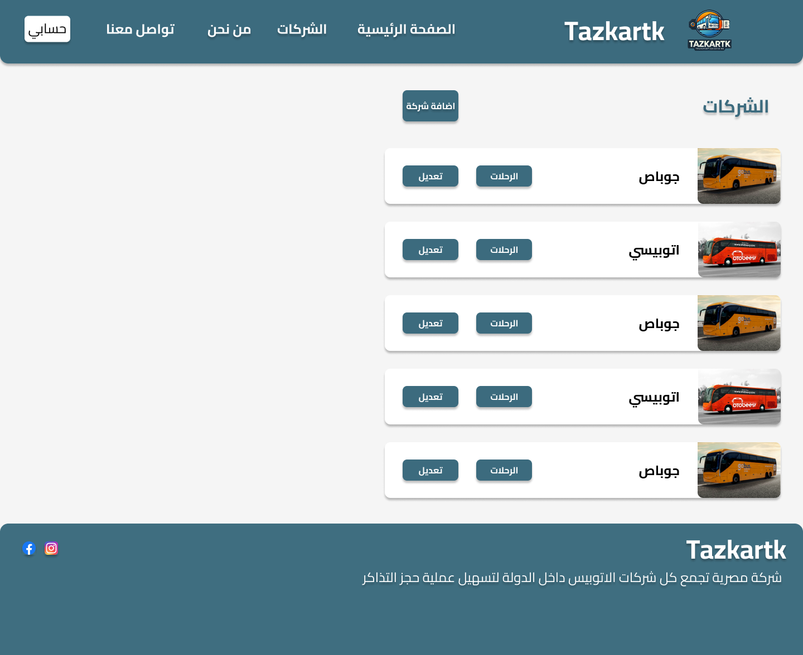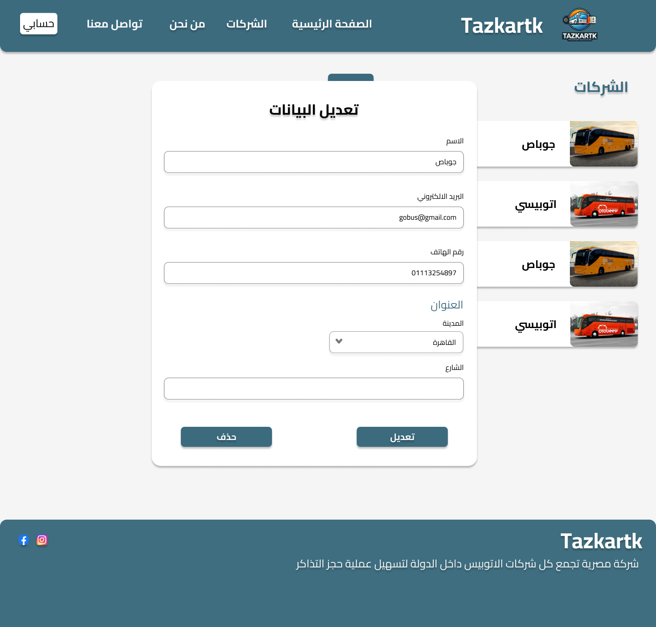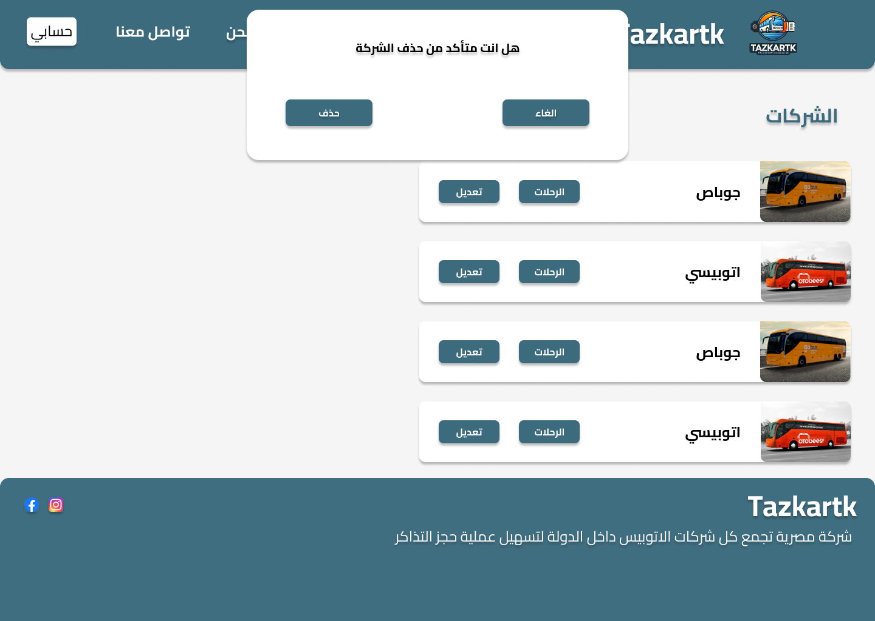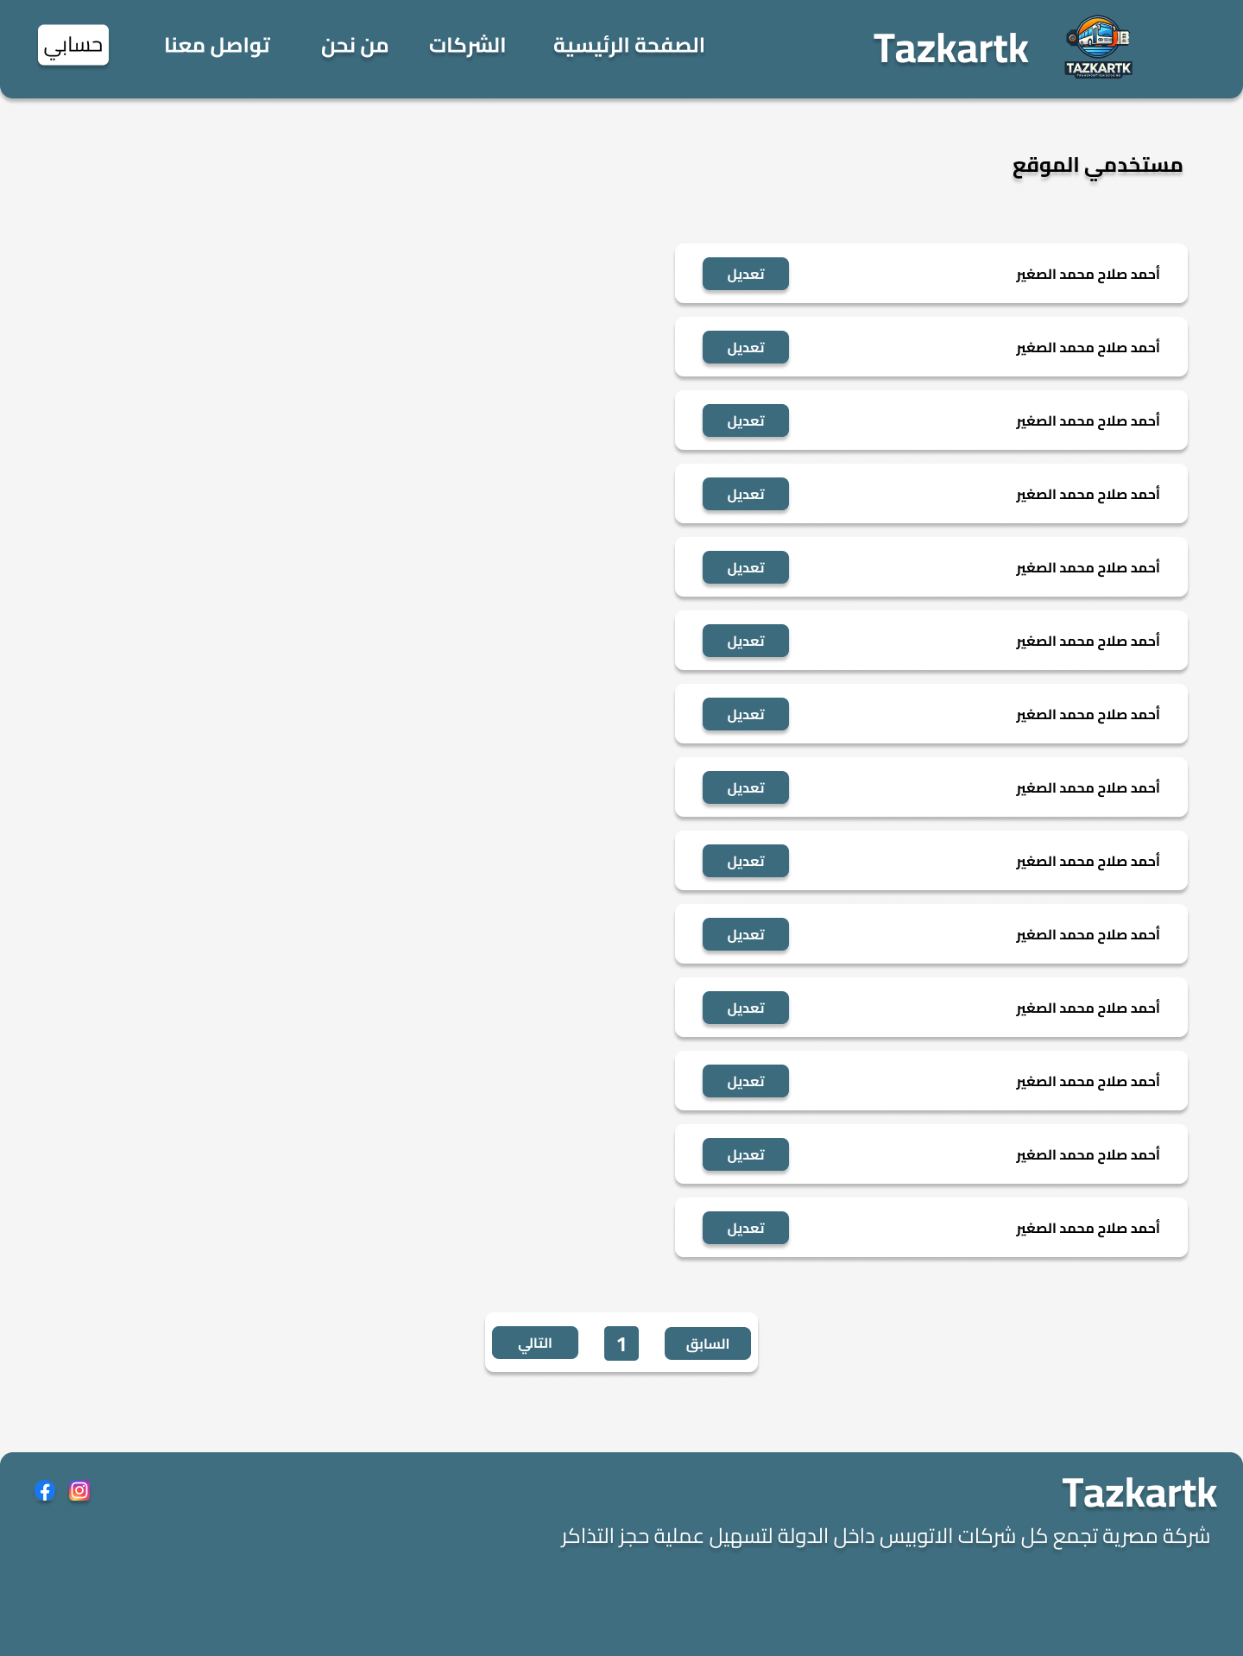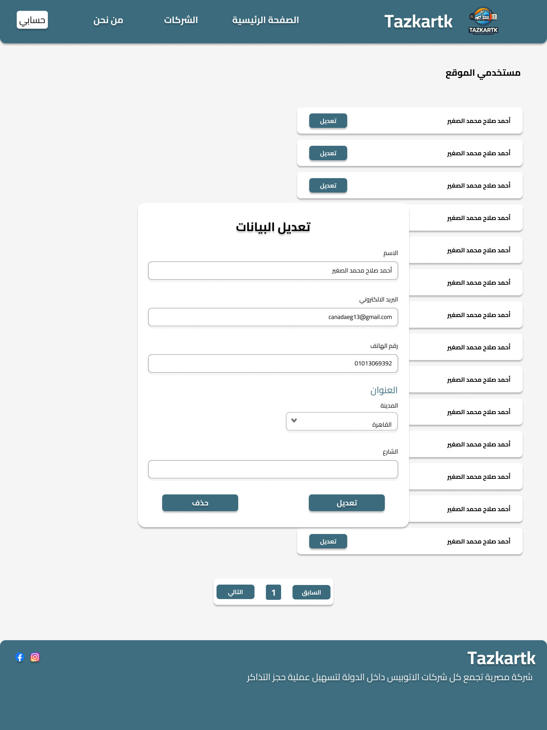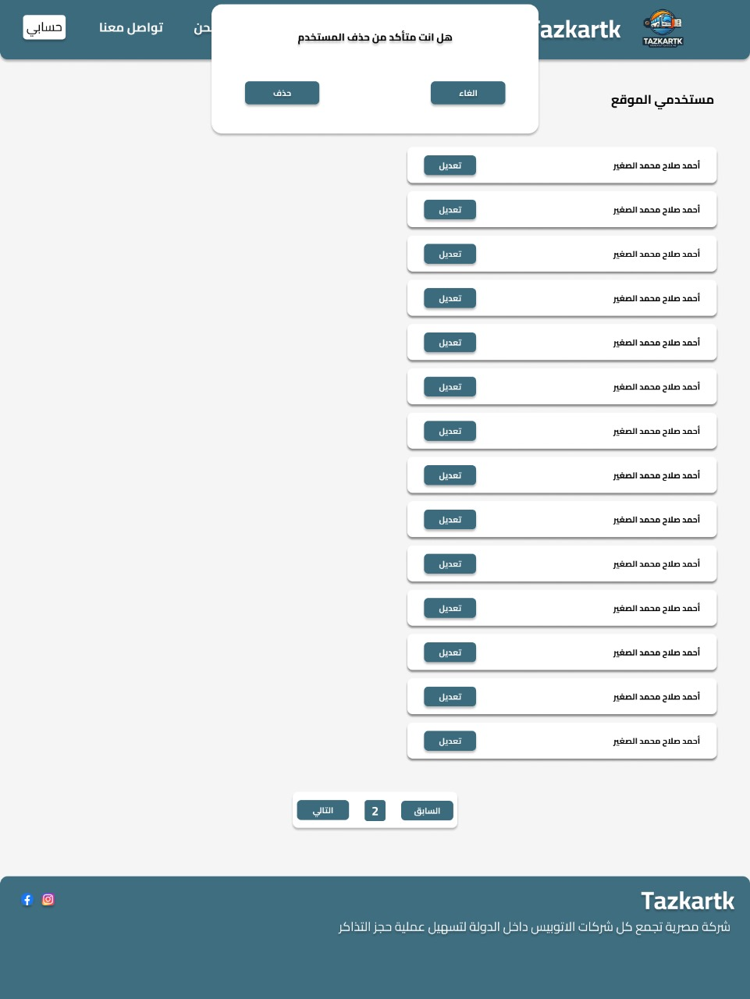

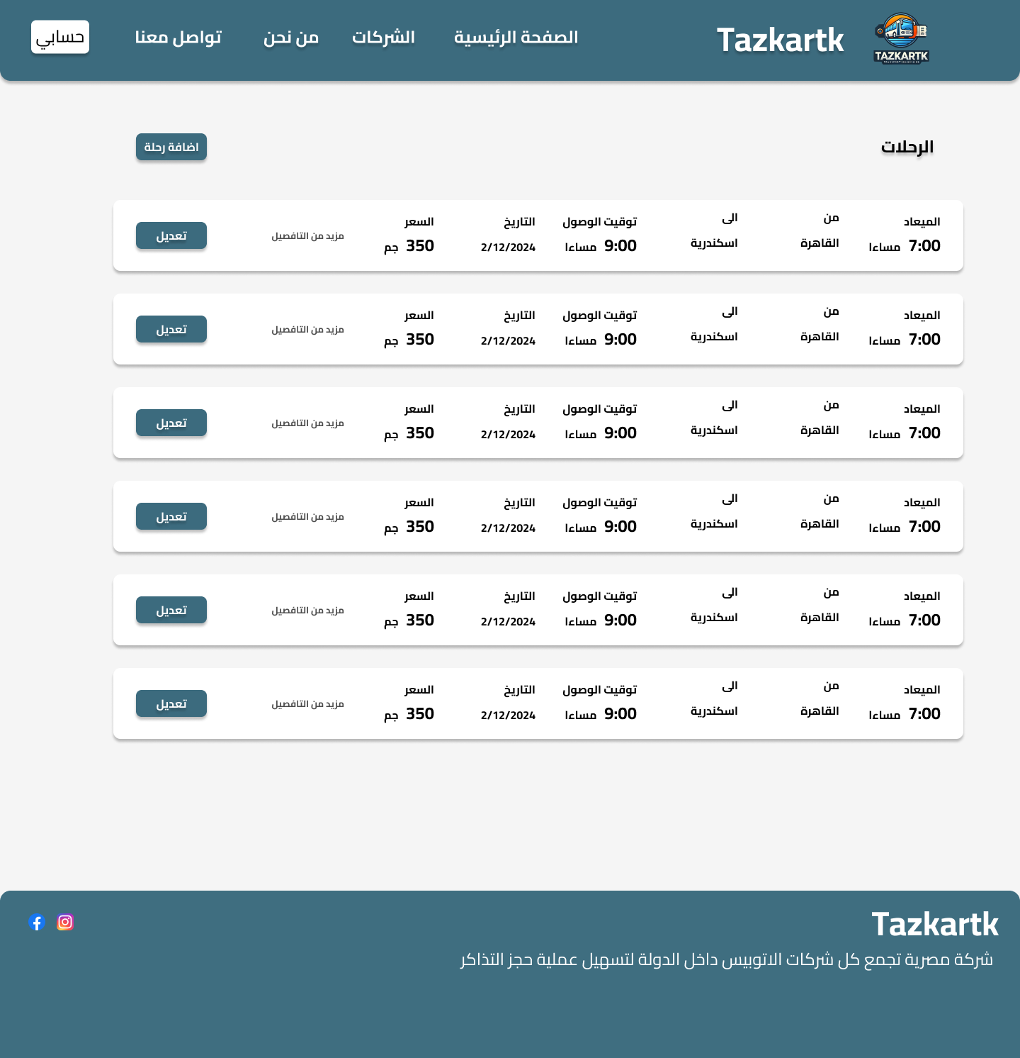

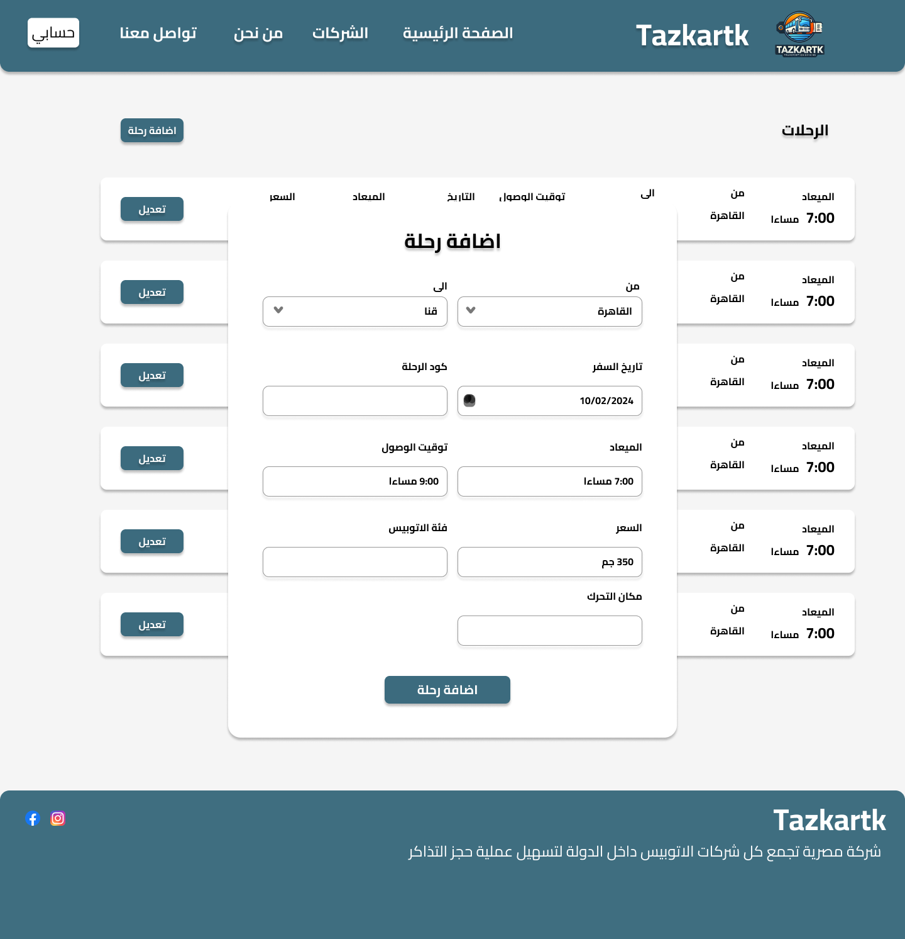

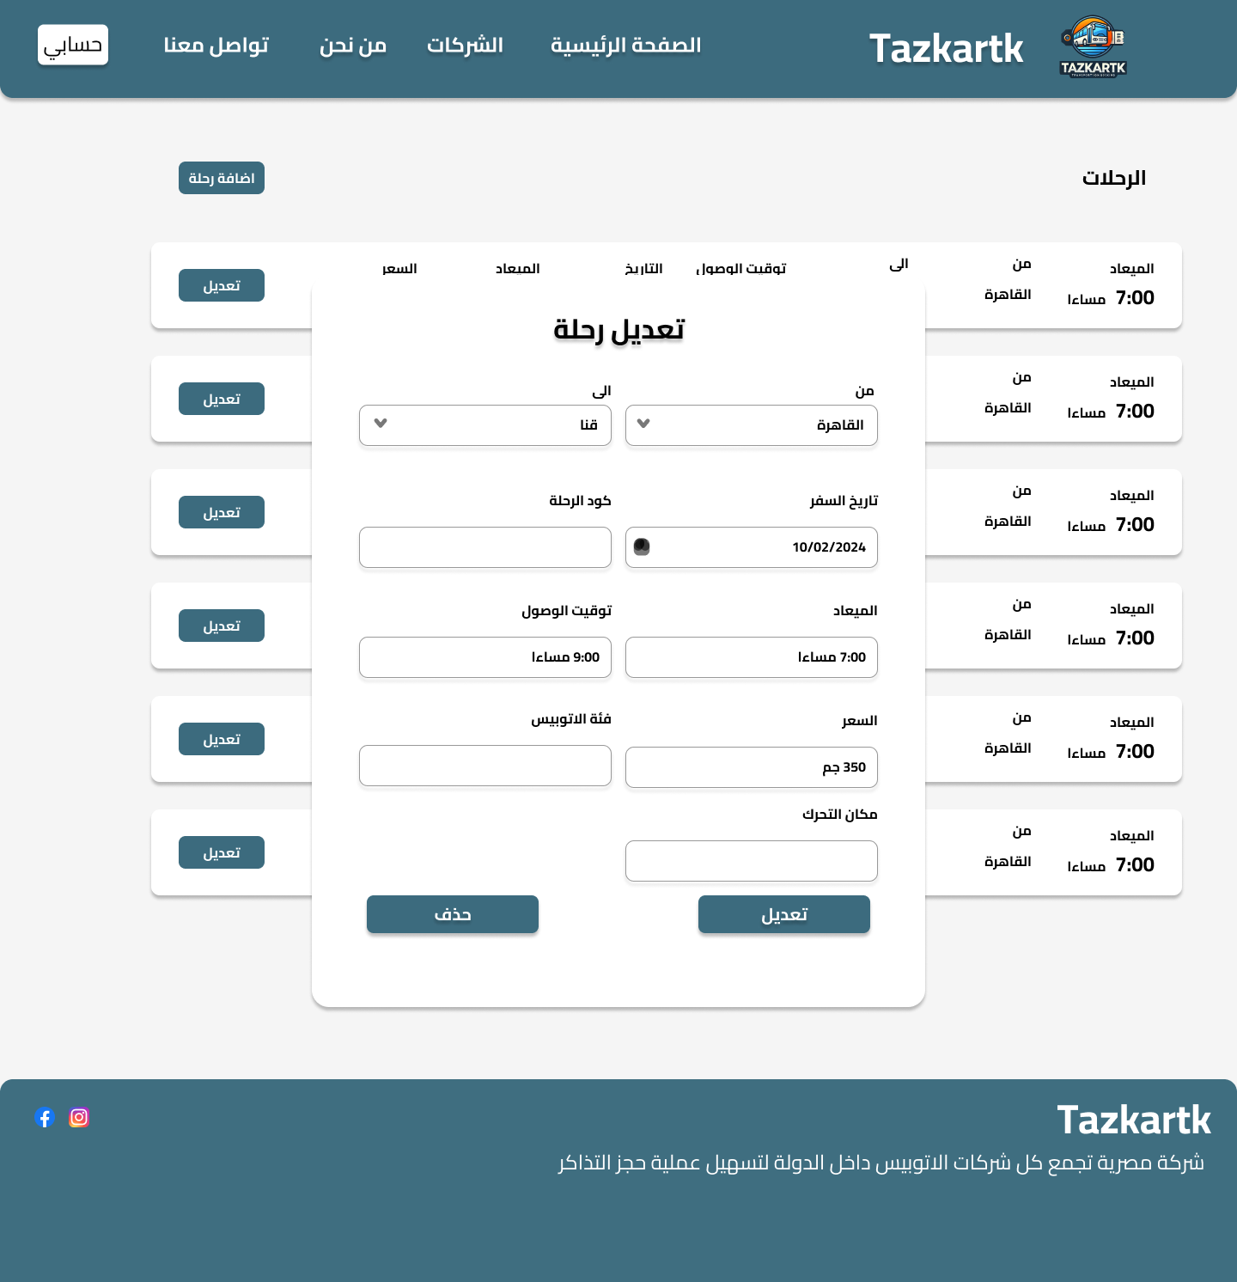

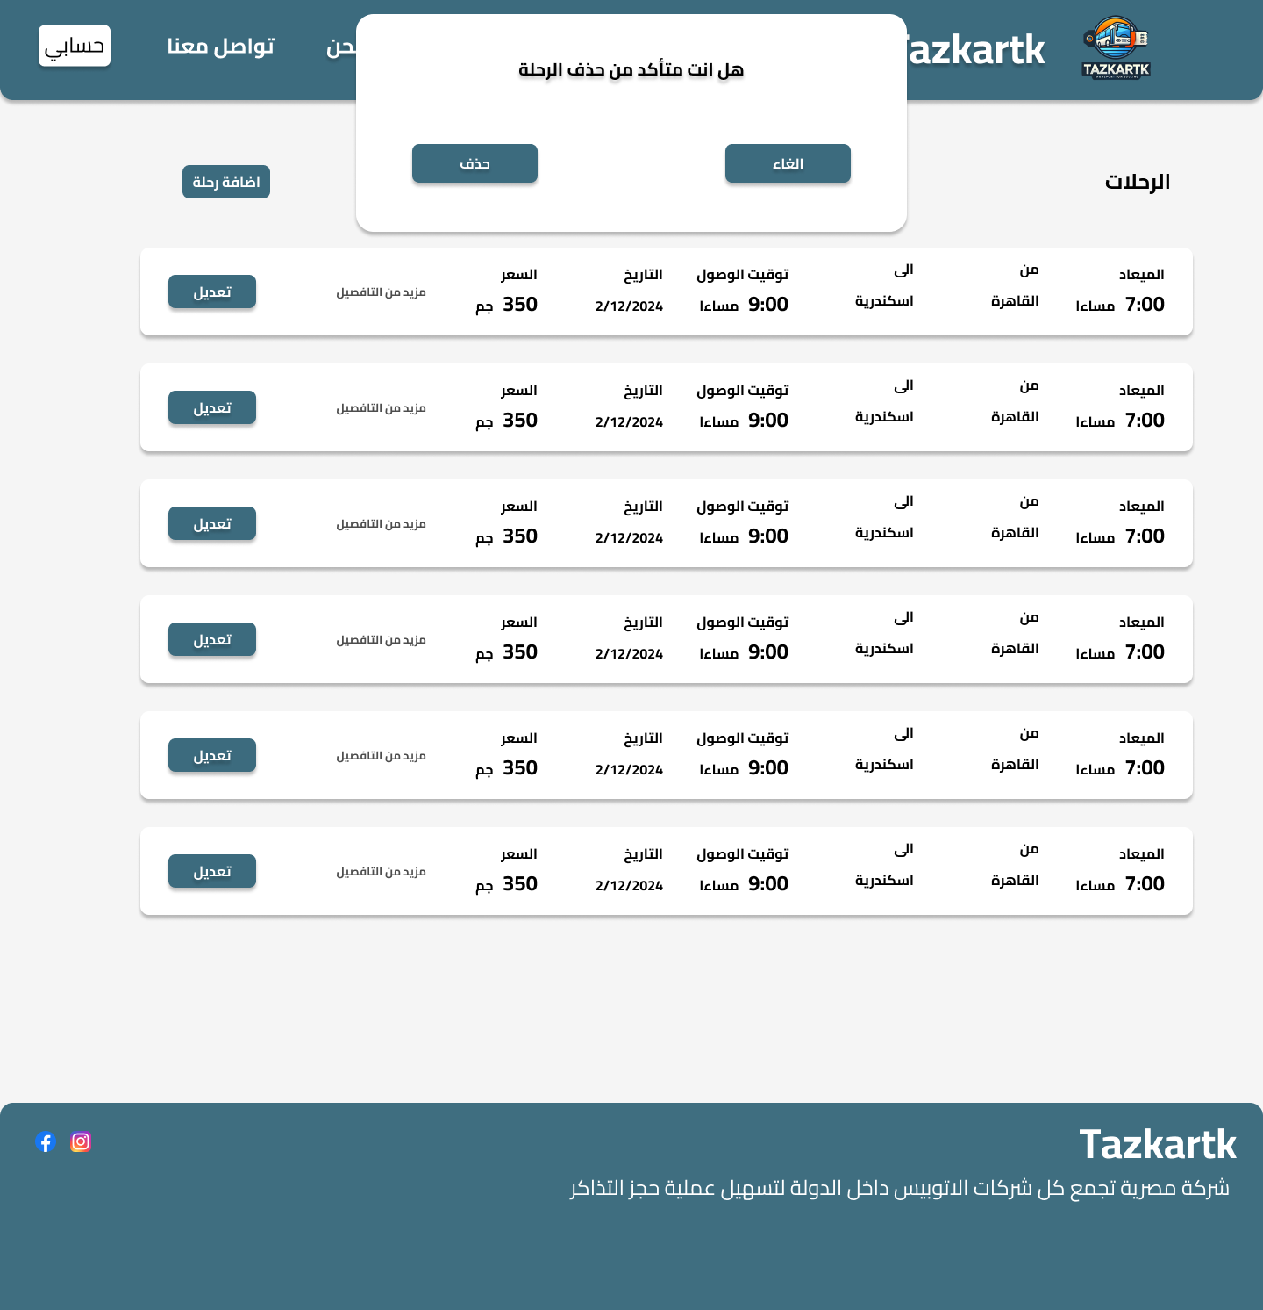

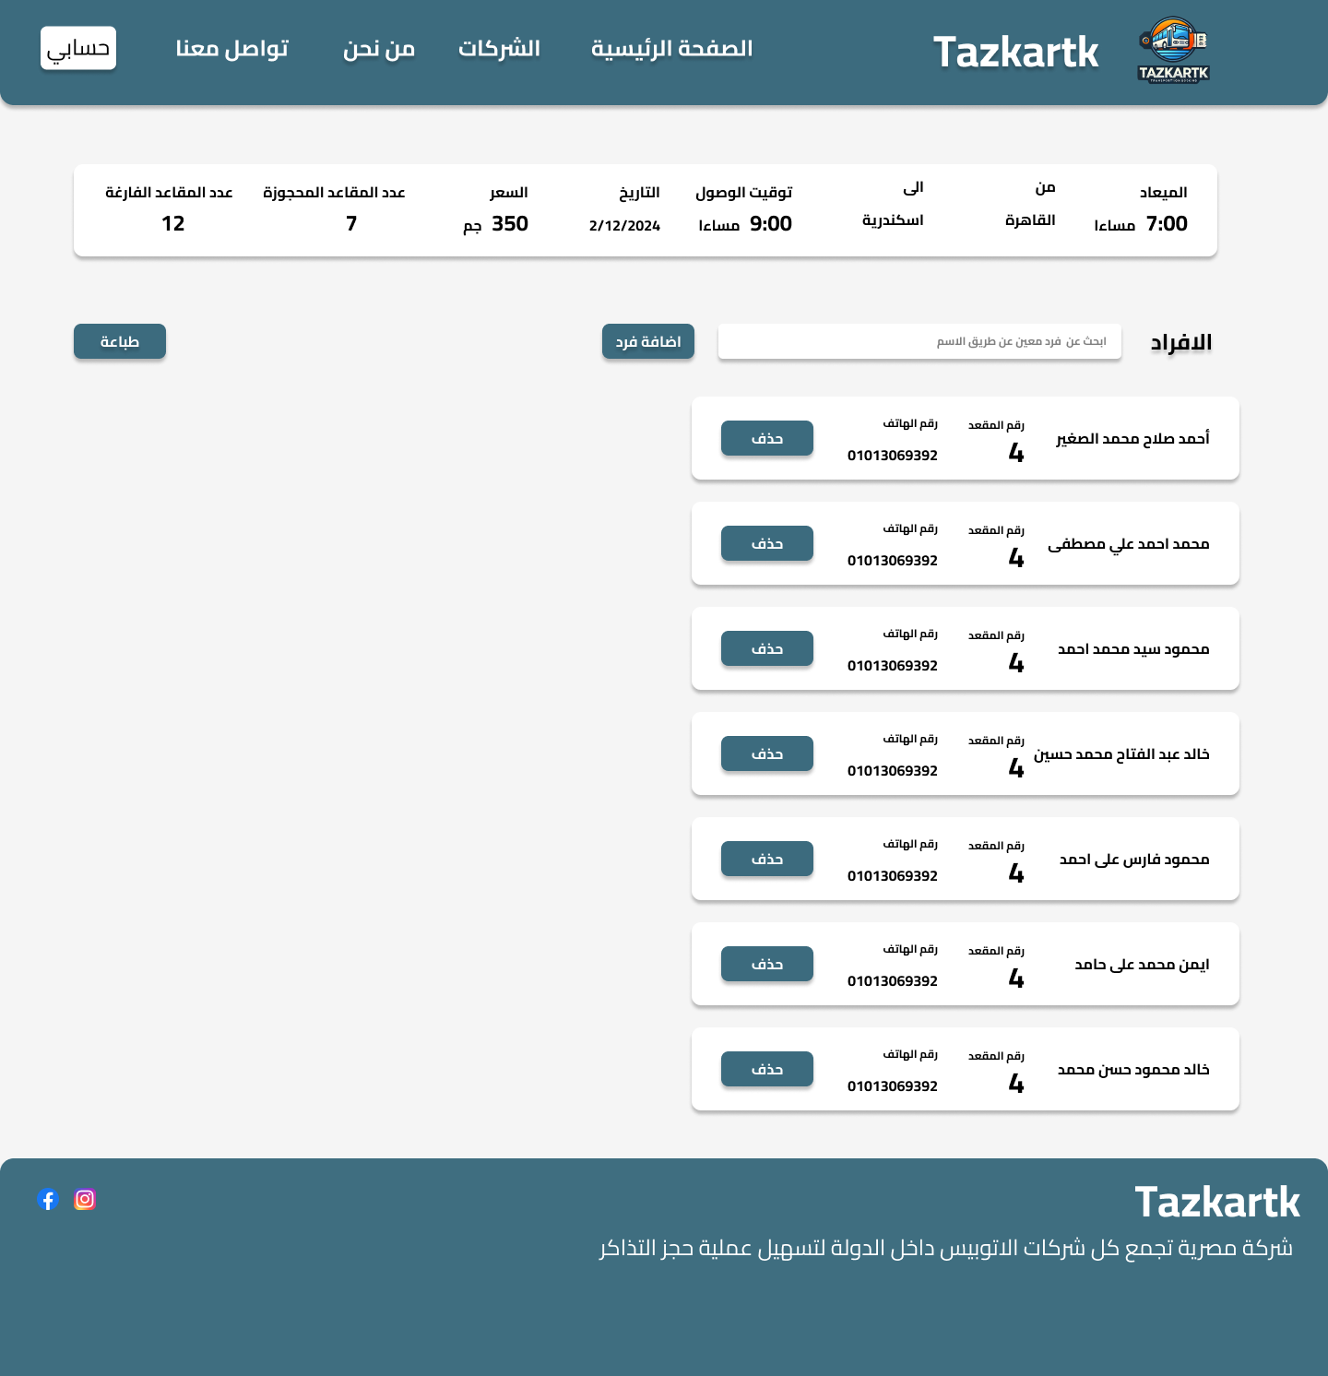

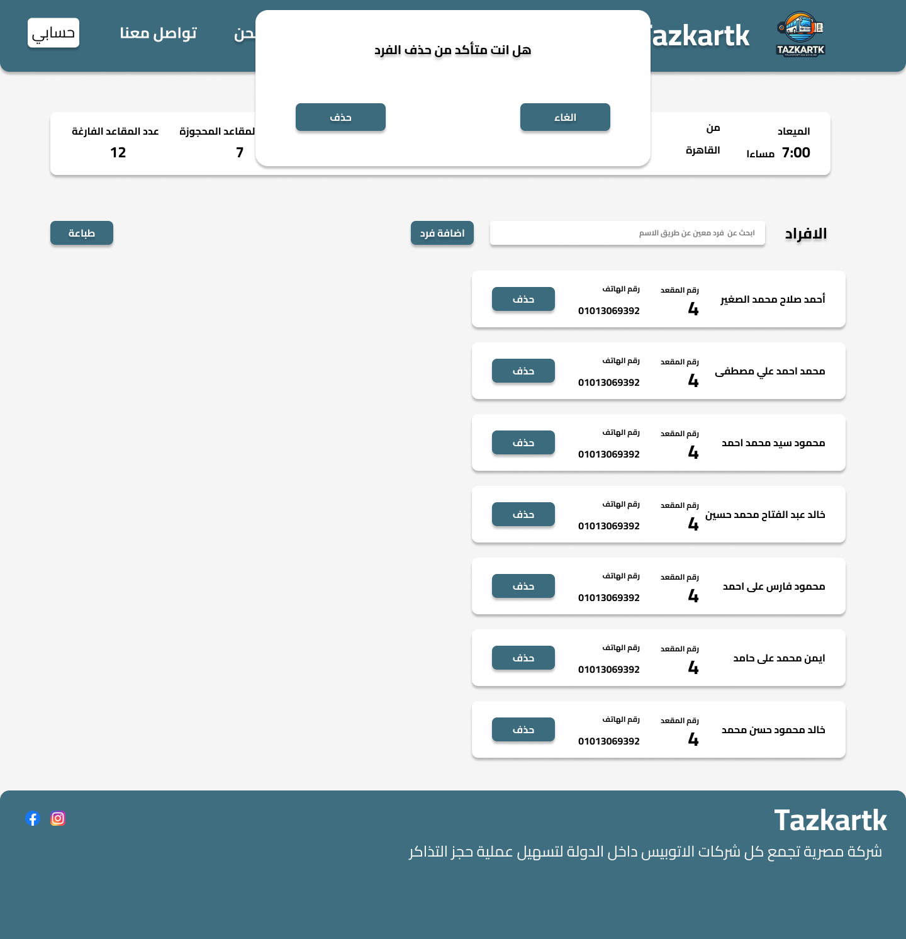

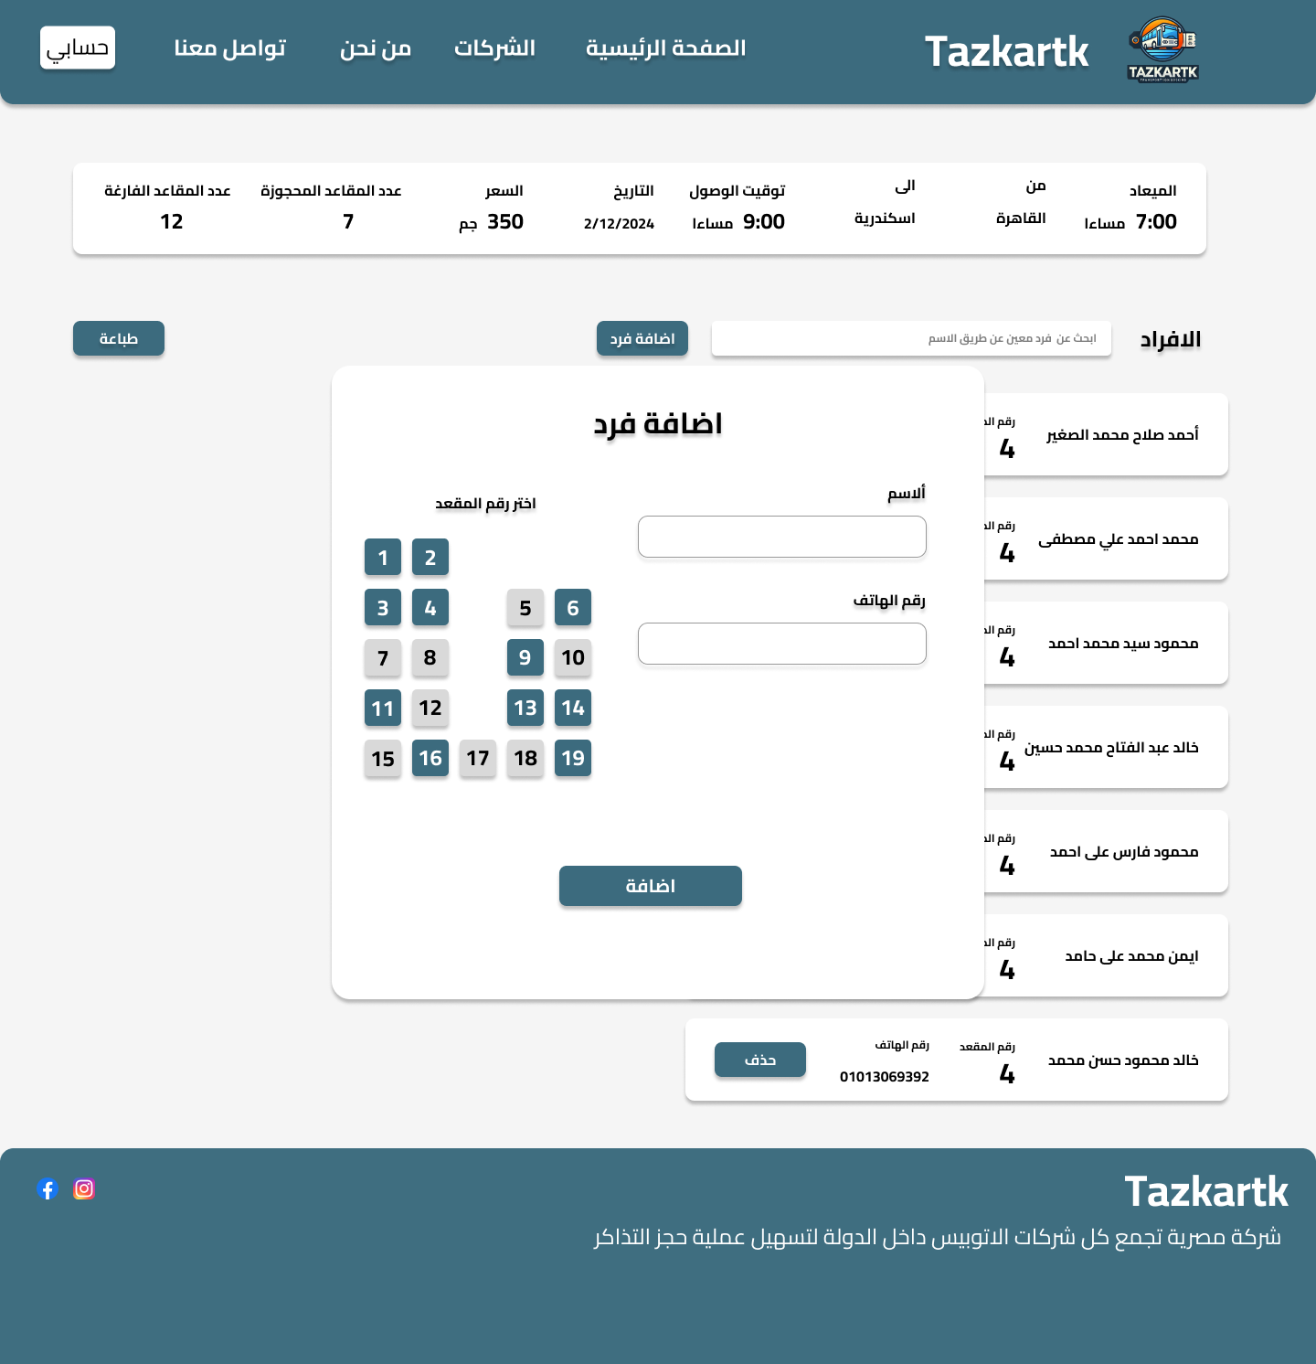

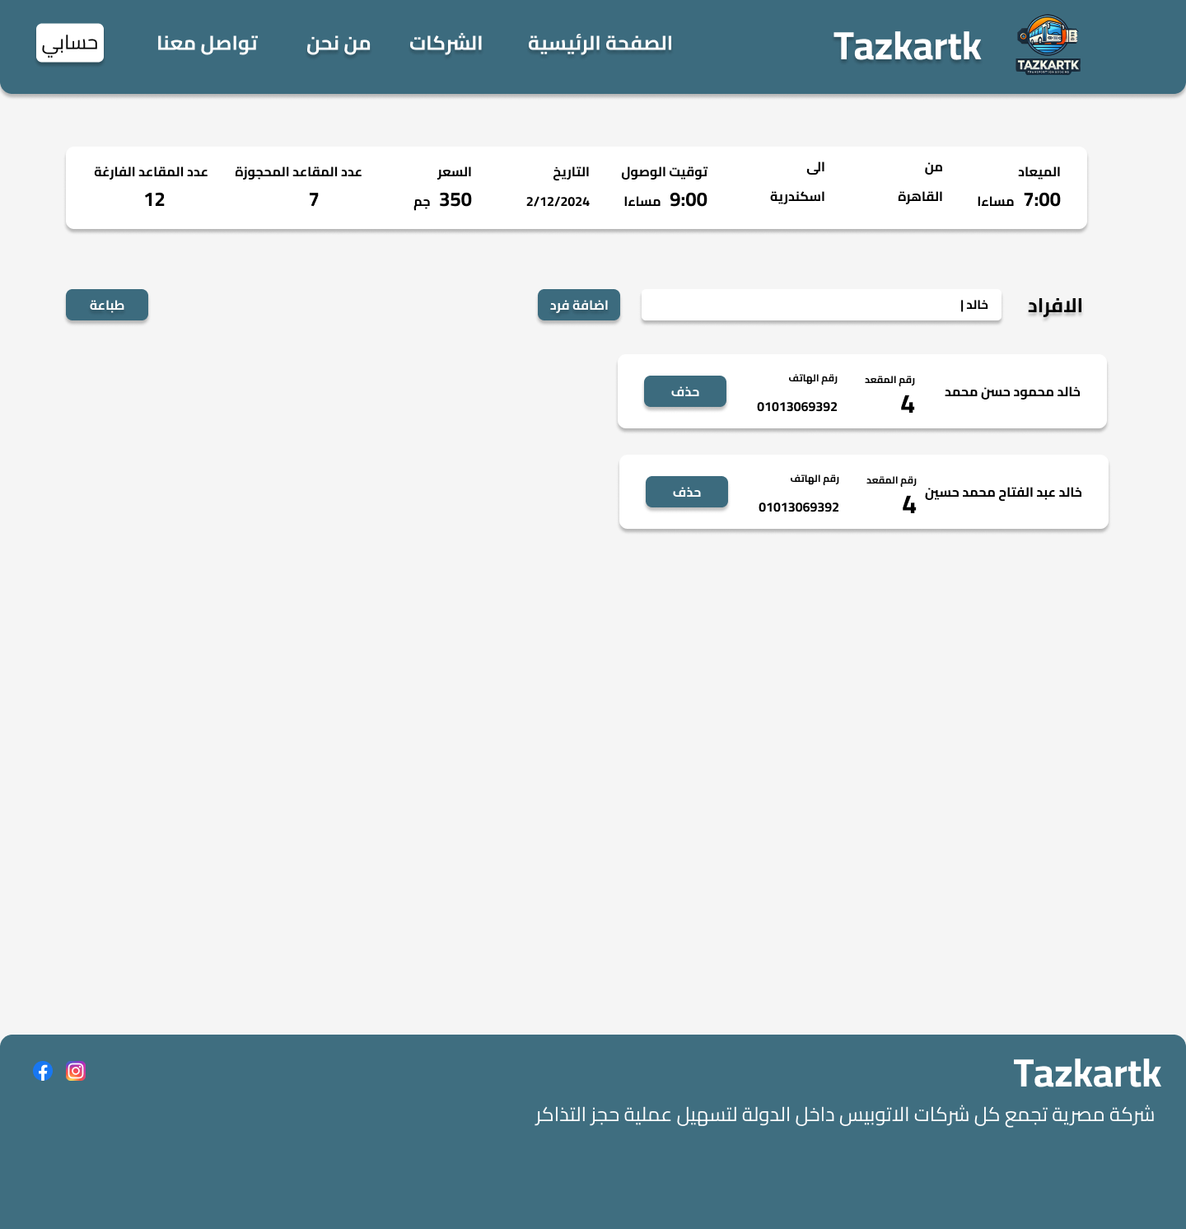

**Company**

